BIO DATA
Name : Nisha MD 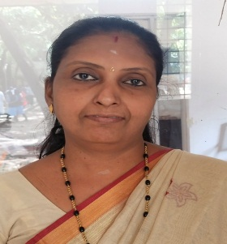

Designation : Assistant Professor

Department : Hindi

College : MES Asmabi College.
P.Vemballur, Kodungallur,
Trissur, Kerala 680671

Address : Vazhoor house
P Vemballur PO
Pin 680 671
Thrissur Dt

Qualification: MA, BEd, MPhil

Phone No : 9544749432

Email : nishadinakaran99@gmail.com

Teaching Experience

17 years’ experience at Hindi Prachara Kendra ,Kodungallur

5years experience at MES Asmabi College ,PVemballur

Membership of National /International bodies

Governing body member of Dakshina Bharath Hindi Prachar Sabha Madras

Paper Presentation

1. Hindi Sahitya mem paryavaran vimarsh” International seminar conducted by Kalladi college and MES Asmabi college held on 7 & 8 December 2019.

2. National Seminar in connection with Azadi ka Amrit Mahotsav"Locating the Legends of India:History & Literature

Seminar Participation

1. Trade and urban formation Reflections on the evolutionary history of Kodungallur
Conducted by IQAC& Malayalam department on17/5/2020.

2 .Challenges in Reporting &editing conducted by Mass Communication & English Department on22/7/20.

3 .Gandhi Chinthan Ki Avasyakatha, International Seminar conducted by Daksina Bharatha Hindi Prachara Sabha Madras on 31/10/20.

4. Reaching as a profession, challenges and opportunities conducted by computer application on12/8/20.

5. Ezhuth Edam anubhavam conducted by Malayalam department on1/11/20.

6. Human compassion in contemporary Hindi fiction conducted by SN college for woman kollam on 16/12/20.

