PROFESSIONAL PORTFOLIO

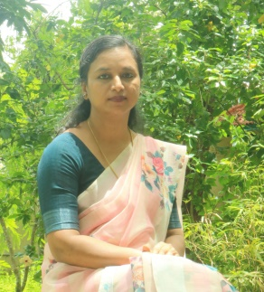
Name- Dr Reena Mohamed PM
Designation- Vice Principal,Assistant Professor & HoD
Department- English
Official Address- Assistant Professor of English
Personal address :Nalakath House,PO Vadanappally, Thrissur
Educational qualifications (PG onwards)
Qualification | Year | University | Class obtained
MA | 2007 | Annamalai University,Tamil Nadu | First
BEd | 2003 | Institute of Advanced Studies in Education,Thrissur | First
PhD | 2021 | Bharathiar University | NA

Date of joining- 01-06-2011
Experience in years- Eleven
Subjects handling
1. Introducing Literature- SemesterI
Appreciating Poetry- Semester II(I BA English)
2.Appreciating Prose-Semester III
Literary Criticism- Semester IV (II BA English)
3. Indian Writing in English and Language and Linguistics– Semester V
4.Film Studies and New Literatures in English- Semester VI(III BA English)
5. British Literature from Chaucer to 18th Century,19th Century Literature and Indian Literature in English- Semester 1,
Literary Criticism and Theory Part 1 and Post Colonial Writings- semester II (I MA English)
6. Twentieth Century British Literature Post 1940, Women’s Writing, Teaching of English- Semester III,
English Literature in the Twenty First Century, Indian English Fiction, Malayalam Literature in English Translation

Area of interest - English Language Teaching and Post Colonial Writings
Specialistaion- English Language and Literature
Publication details (in API format of referencing)
Publications during the last 2 years

Category | Title | Issue/ Proceedings including Impact Factor/ ISSN | Year
National Journal | “Dismantling Rasa in Life of Pi”  Journal of the Asiatic Society of Mumbai | 0972-0766 | CARE list  Vol XCV  No.30  2022
National Journal

Paper presentation details –presented a paper in National seminar
FDP/PDP attended-
- 2 refresher courses, 1 FDP

Major Seminar/Workshop participation-
- Participated in 10 seminars

Conference/seminar chaired- 1
Acted as resource person/ Invited lectures delivered- Nil
Additional duty other than teaching in the Department-
Vice Principal
IQAC- Member,Advisory Board
Presiding Officer,Internal Compliance Committee
Convenor-Grievance Redressal Cell
Research interest and activities- Psychoanalytical studies
Professional membership- Member in Indian Society of Training and Development
Awards and recognition- NIL
Consultancy services- NIL

