Report on Orientation Session: Introduction to FYUGP Framework
Organized by the Department of Economics
MES Asmabi College, P. Vemballur
Date: 11 July 2025 | Time: 11:30 AM | Venue: Seminar Hall
The Department of Economics, MES Asmabi College, P. Vemballur, organized an informative orientation session on “Introduction to FYUGP Framework” on 11th July 2025 at 11:30 AM in the Seminar Hall. The programme aimed to provide clarity on the recently implemented Four-Year Undergraduate Programme (FYUGP) under the National Education Policy (NEP) 2020.
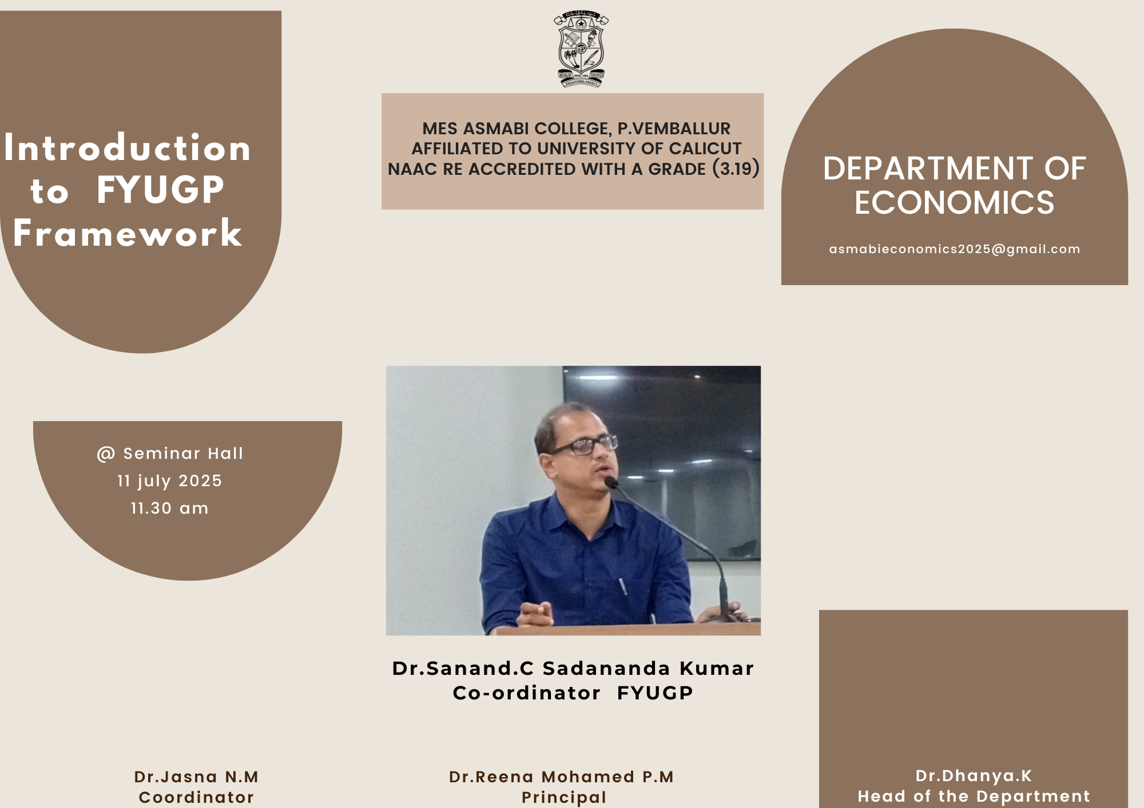

Resource Person:
The session was led by Dr. Sanand. C Sadananda Kumar, Coordinator of FYUGP, who served as the key speaker. He provided valuable insights into the structure, objectives, and benefits of the FYUGP model.

Dignitaries:
- Dr. Reena Mohamed P.M, Principal of MES Asmabi College, delivered the presidential address and emphasized the importance of academic transitions in enhancing student potential.
- Dr. Dhanya K, Head of the Department of Economics, welcomed the gathering and highlighted the relevance of FYUGP in today’s globalized academic environment.
- Dr. Jasna N.M, Programme Coordinator, managed the event proceedings with efficiency and ensured effective communication of the new curriculum framework to the participants.
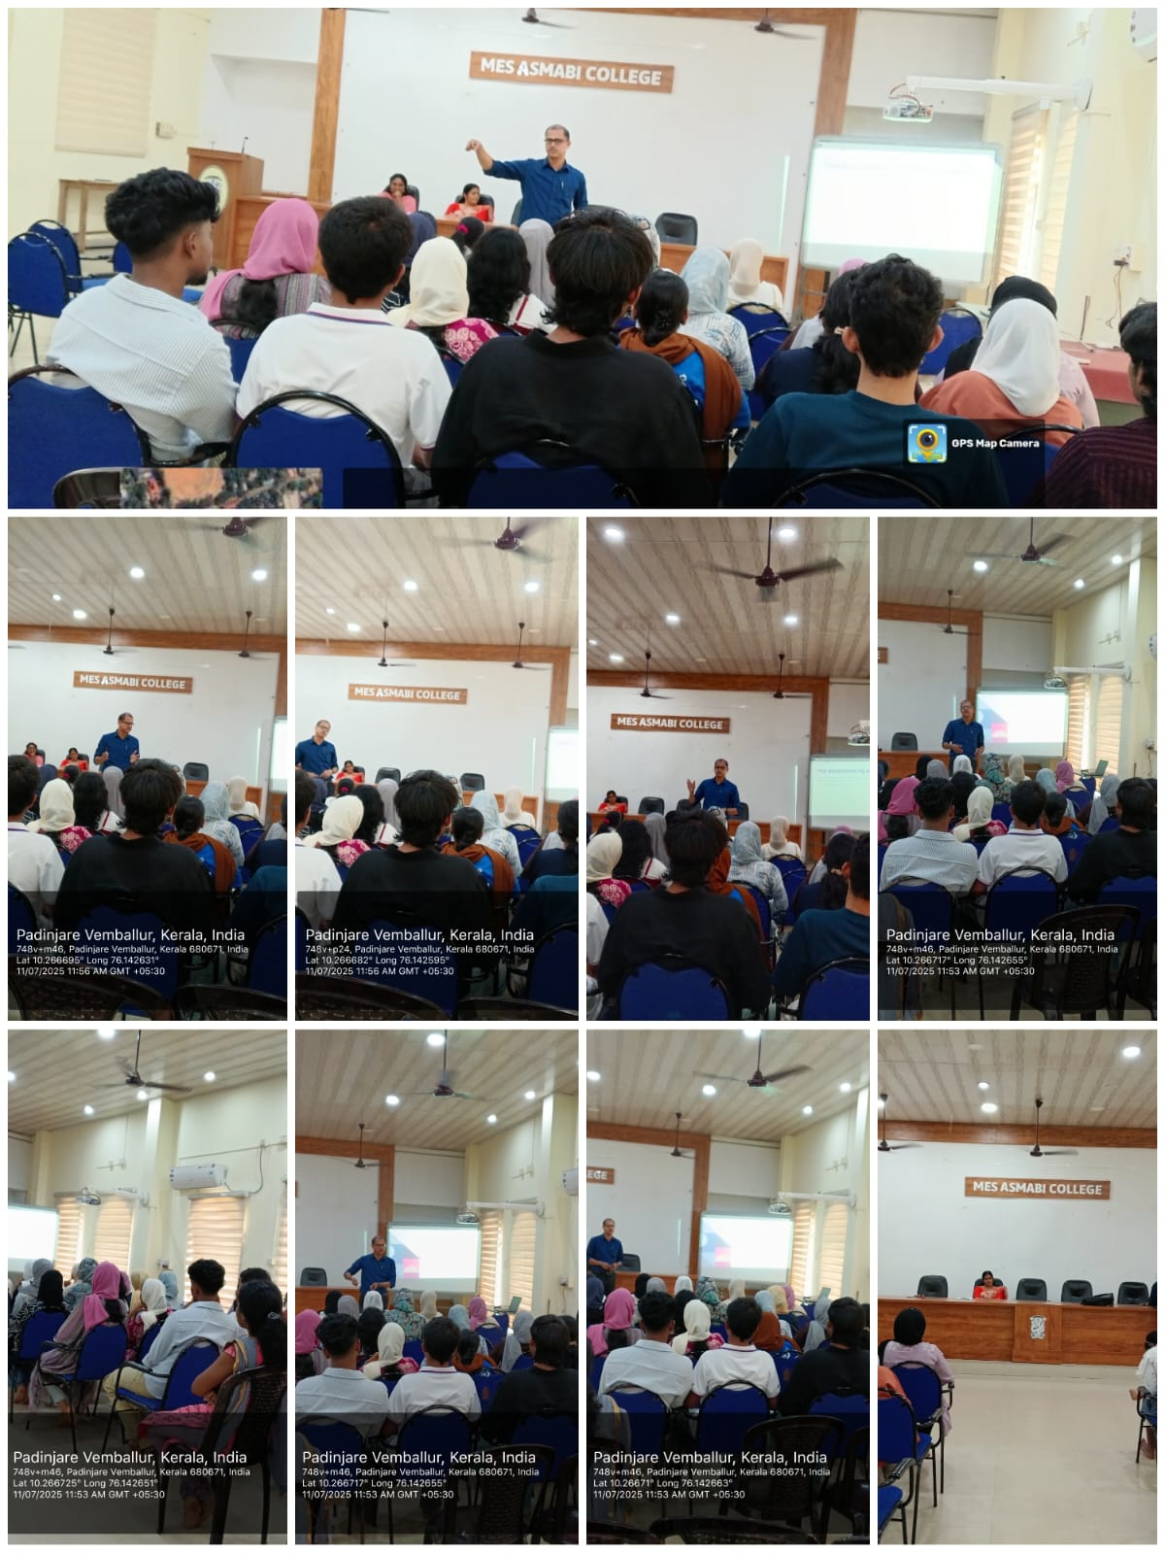

Programme Highlights:
- Explanation of FYUGP Structure: Dr. Sanand C elaborated on the key components of the FYUGP including flexibility in subject choices, multiple entry-exit options, skill development integration, and outcome-based learning.
- Benefits to Students: He stressed how the framework aims to empower students with multidisciplinary knowledge, improve employability, and align Indian education with international standards.
- Interactive Q&A Session: Students and faculty raised several questions regarding credit distribution, internships, research options, and evaluation methods. The speaker answered all queries comprehensively.

Outcome:
The session provided much-needed clarity to students and faculty about the structural and academic reforms introduced by the FYUGP. It helped the attendees understand how to adapt to the new learning framework effectively.

Conclusion:
The Department of Economics successfully hosted a timely and enlightening session on FYUGP. The programme marked an important step in preparing the academic community of MES Asmabi College to embrace the transformative changes brought in by NEP 2020.

