REPORT ON IDEA HACKATHON
Organized by: Department of Economics, MES Asmabi College, P. Vemballur
Date: 30th June 2025
Venue: MS 07
Time: 1.30 PM

The Department of Economics, MES Asmabi College, successfully organized an "IDEA HACKATHON" on 30th June 2025 at 1.30 PM in room MS 07. The event aimed to foster innovation, critical thinking, and collaborative problem-solving among students by encouraging them to brainstorm and develop creative ideas related to economic and developmental issues.
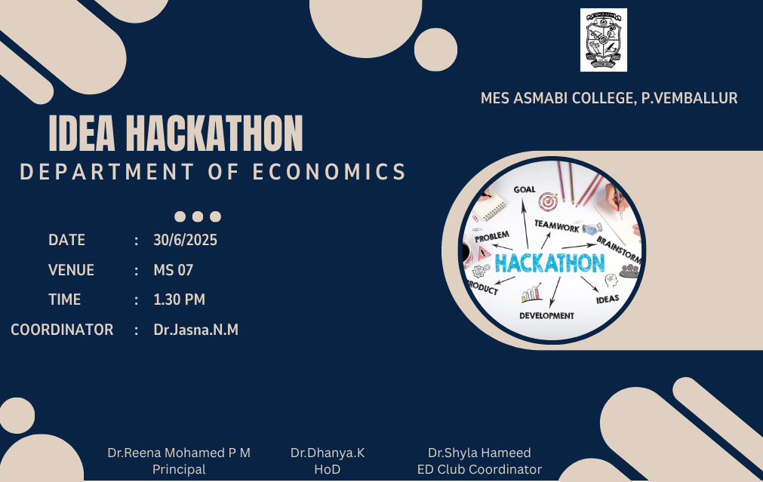
The programme was coordinated by Dr. Jasna N.M, who guided the participants throughout the event and ensured its smooth conduct. Students actively took part in team-based activities, presenting innovative solutions to various socio-economic challenges. The hackathon focused on topics like development, teamwork, product ideation, and goal-oriented planning.
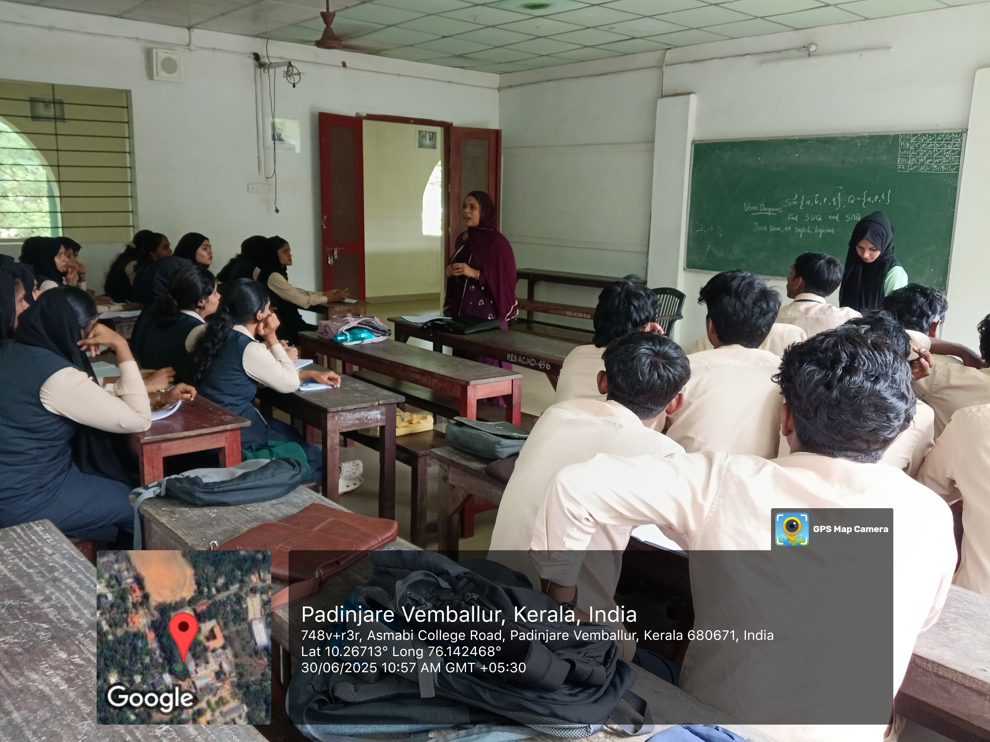
The event was graced by the presence of Dr. Reena Mohamed P M (Principal), Dr. Dhanya K (Head of the Department of Economics), and Dr. Shyla Hameed (ED Club Coordinator), who appreciated the enthusiasm and creativity displayed by the students.
The hackathon provided a platform for young minds to think innovatively and work collaboratively, fostering a spirit of entrepreneurship and economic insight among students.
Outcome:
- Promoted critical and innovative thinking.
- Enhanced problem-solving and presentation skills.
- Encouraged teamwork and leadership among participants.
The Department looks forward to conducting similar events in the future to nurture talent and promote experiential learning.

