DEPARTMENT OF ECONOMICS
M E S ASMABI COLLEGE, P. VEMBALLUR
II B.A ECONOMICS
Tutorial Report 2024-25

Tutor :ShanilkumarAyyappan

III semester Classes started 17/07/2024
Total Number of students in the Class: (Boys 15, Girls 41)
Class representatives: Fathima P.K and AyshaFida
PTA meeting conducted on 07/10/2024
TIME: 1.30 PM to 4 PM
VENUE: MEETING CONDUCTED in MS 06
Agenda:
I. Progress report analysis.
II. Feedback collection from parents relating to vaious classes
III. Other issues regarding student support if any.
Teachers Present:
- DrDhanya K(HOD)
- Dr.Shyla Hameed
- Dr. Jasna N.M
- Dr.JeslaGalibdeen P
- Dr.Sanand.C
- Dr.Rashmi.S
- Dr.Basheer P.T
- Shanilkumar

Parents reported: Parents reported: 46(parents of the rest 10 students informed thetutor regarding absence).

Performance Analysis: The result analysis of Second sem universityexamination was taken up for discussion. The performance of each student in comparison with the overall performance of the students were intimated to parents.

- HOD, Dr.Dhanya.K informed about attendance and attentiveness in class and explained about how to manage the class with available Time.
- Tutor explained the overall performance of students.
- Parents had some suggestions regarding classes. HOD accepted all the suggestions wholeheartedly.
- Difficulties if any in learning faced each student were discussed. So also parents and students were asked to freely express their opinion/comments regarding teaching methods adopted by all teachers.46parents engaged in discussion.

- The result analysis of Class examination was also taken up for discussion.
- Difficulties if any in learning faced each student were discussed. So also parents and students were asked to freely express their opinion/comments regarding teaching methods adopted by all teachers.
- Parents of poor and slow learners were given advice to have a special attention on them. The reasons for failure in subjects mentioned by majority of students were difficulty in studying the lessons in English language and the dearth of time in preparing for the examination.
- No cases of insufficient attendance and lack of punctuality were reported.

IV Semester Class started on 06/12/2024.
Two internal exams were conducted for the students.
PG Department of Economics: A Year of Active Participation

The PG Department of Economics at MES Asmabi College has had a productive year, with a range of programs and activities that witnessed active participation from all students, including the second-year students.

Student Participation

It is noteworthy that the second-year students were actively involved in all the programs conducted by the department. Their enthusiasm and participation added to the success of the events and demonstrated their commitment to academic excellence.
Department's Initiatives
The department's initiatives, including seminars, workshops, and conferences, provided students with opportunities to engage with academic and industry experts, develop their research skills, and showcase their talents.
Achievements
The active participation of students in the department's programs has yielded several achievements, including:
- Successful completion of various academic and co-curricular events
- Enhanced research and presentation skills among students
- Stronger bonding among students and faculty members.
Students actively participated in the below programs
1: Population Day Essay Writing Competition
The second UG students of the Economics Department actively participated in the Population Day essay writing competition. The event aimed to raise awareness about population-related issues and encouraged students to express their thoughts and ideas through essays. Our students showcased their writing skills and creativity, making the event a success.
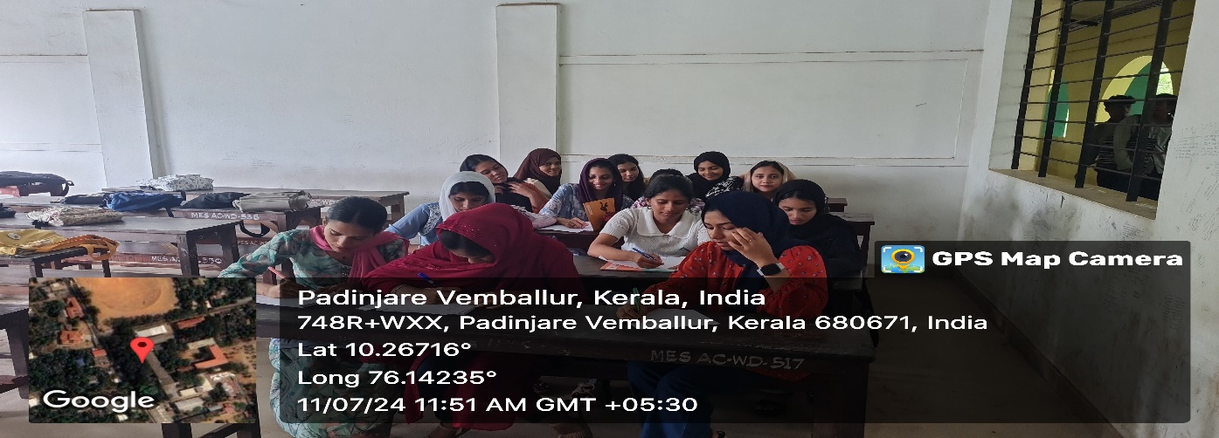

2: RBI Visit

On January 14, 2025, the second UG students of the Economics Department visited the Reserve Bank of India (RBI) as part of their academic curriculum. The visit provided students with a unique opportunity to learn about the RBI's functions, monetary policy, and banking regulation. Our students actively participated in the visit, clarifying their doubts and gaining valuable insights.
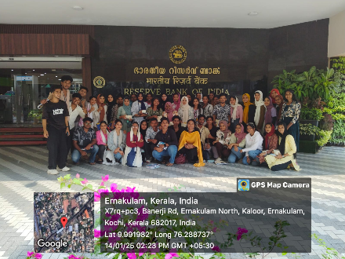

3: KILA Visit and Residential Camp

The second UG students of the Economics Department participated in a visit to the Kerala Institute of Local Administration (KILA) and a residential camp from February 27 to 28, 2025. The event aimed to provide students with hands-on experience in local governance and administration. Our students actively engaged in the camp's activities, learning about decentralization, local self-government, and sustainable development.
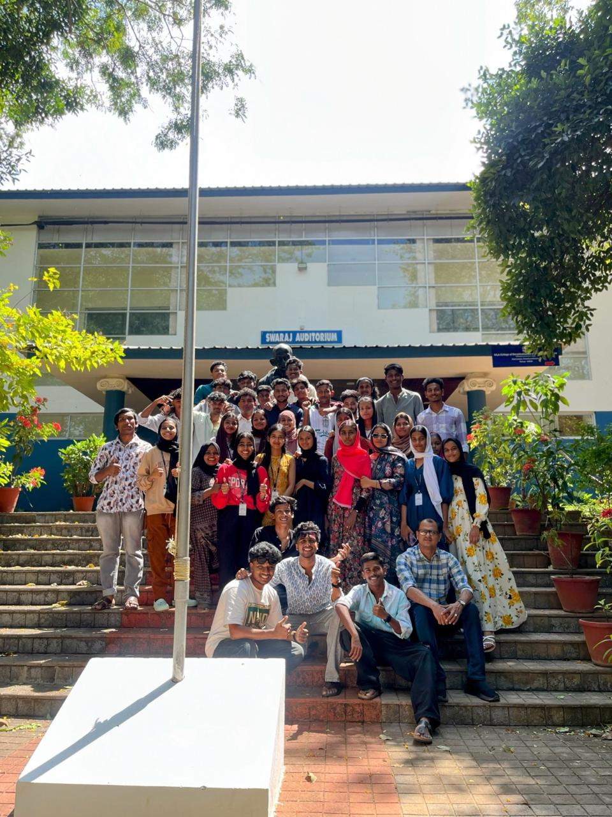

4: Economics Association Day Inauguration

The Economics Department celebrated its Association Day on February 3, 2025. The second UG students played an active role in organizing the inauguration function, which included various cultural programs, speeches, and activities. The event aimed to foster a sense of community among students and faculty members.
5: Interdepartmental Quiz Competition
The second UG students of the Economics Department participated in an interdepartmental quiz competition on February 3, 2025. The event tested students' knowledge in various subjects, including economics, history, and current affairs. Our students showcased their academic prowess, competing with teams from other departments.
6: Interdepartmental Dance Competition
The second UG students of the Economics Department participated in an interdepartmental dance competition on February 4, 2025. The event provided a platform for students to showcase their dancing talents, competing with teams from other departments.Aswathy K.U from II B.A Economics won the Second Prize.Our students performed enthusiastically, entertaining the audience with their energetic dance routines.
7: Union Budget Discussion (July 2024)
The Economics Department organized a discussion on the Union Budget on July 23, 2024. The second UG students actively participated in the discussion, analyzing the budget's key features, implications, and impact on the economy. The event aimed to foster critical thinking and economic awareness among students.
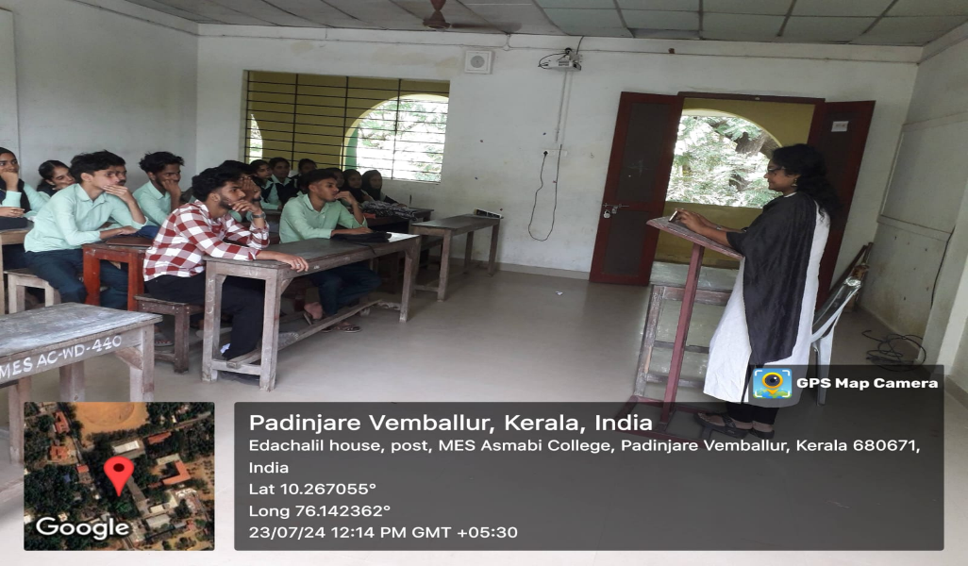

8: Union Budget Discussion (February 2025)
The Economics Department organized another discussion on the Union Budget on February 3, 2025. The second UG students participated in the discussion, examining the budget's allocations, policies, and economic implications. The event encouraged students to think critically about the budget's impact on the economy and society.
9: NSS and NCC Activities
The second UG students of the Economics Department actively participated in social activities through the National Service Scheme (NSS) and National Cadet Corps (NCC). Students engaged in community service, environmental conservation, and social welfare activities, demonstrating their commitment to social responsibility and community development.
10: Cricket Tournament
The second UG students of the Economics Department participated in a cricket tournament at the university level. Our students showcased their sporting skills, teamwork, and determination, contributing to the team's success. The tournament provided a platform for students to develop their physical and mental abilities, while promoting sportsmanship and camaraderie.Vinayak Sivan from second B.A Economics were a member in the College Cricket team.
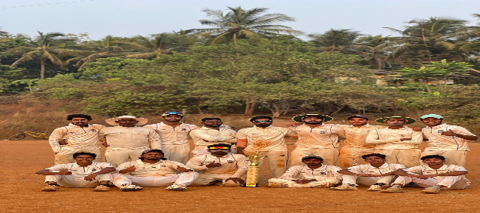
11: Research Methodology Workshop

The second UG students of the Economics Department participated in a Research Methodology Workshop on October 29, 2024. The workshop was conducted by Dr. Prasanth A.P, Assistant Professor, AmrithaViswaVidyapeetham, Kochi.
The workshop aimed to equip students with the fundamental principles of research methodology, including research design, data collection, and data analysis. Dr. Prasanth shared his expertise, providing students with practical insights and hands-on experience.
The workshop was highly interactive, with students engaging in discussions, group activities, and presentations. The event was a huge success, with students gaining a deeper understanding of research methodology and its applications in economics.
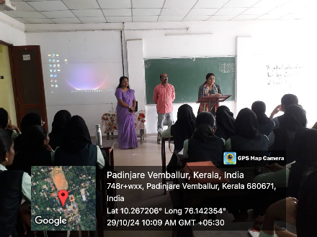

12: Add-on Course on Research Methodology

The second UG students of the Economics Department successfully completed an Add-on Course on Research Methodology during the academic year. The course aimed to provide students with advanced training in research methodology, enabling them to design and conduct research projects independently.
The course covered topics such as research design, sampling techniques, data collection methods, and statistical analysis. Students were required to complete assignments, projects, and presentations, demonstrating their understanding of research methodology.
13.Participation in Cultural Programs during NAAC Visit
Date: August 21-22, 2024
As part of the NAAC (National Assessment and Accreditation Council) visit to our institution, the students of Second BA Economics actively participated in various cultural programs organized on August 21, 2024. The participation of Second BA Economics students in the cultural programs related to the NAAC visit was a resounding success. Their enthusiasm, creativity, and team spirit were evident throughout the events, and they did our institution proud. We congratulate our students on their outstanding performances and look forward to their continued participation in such events.
14. Anti-drug Debate Competition
As part of the activities organized by the Debate Club, MES ASMABI College, PVemballur, conducted a debate in Economics department, on the topic "Life is Better Without Drugs "on 18/2/2025. The event aimed to raise awareness about the harmful effects of drug use and promote healthy lifestyles among students.
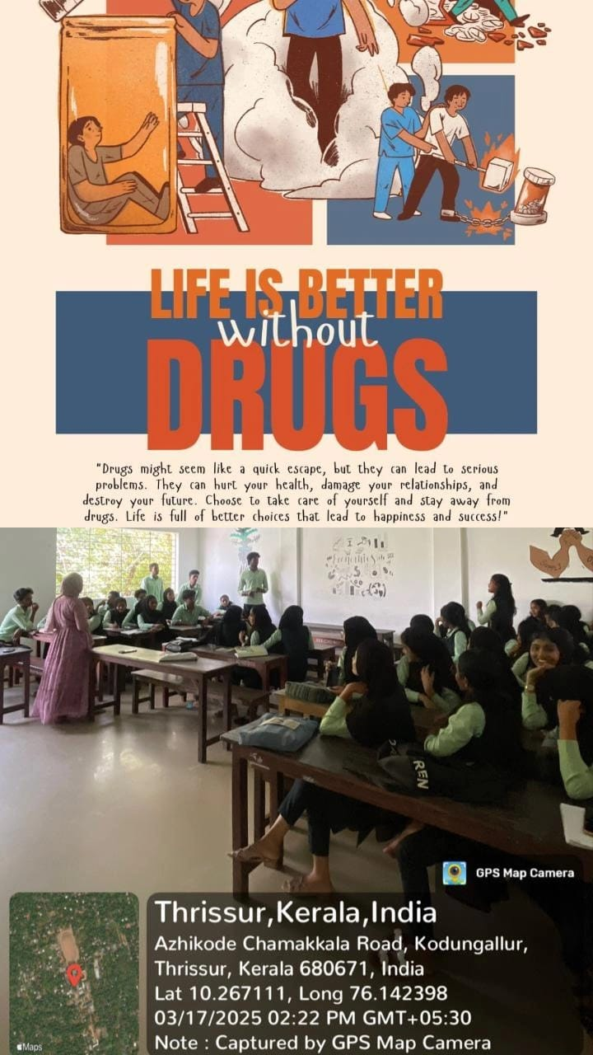

Conclusion

The PG Department of Economics is proud of its students' achievements and appreciates their active participation in the department's programs. We look forward to another year of academic excellence and student engagement.

Sd/- Sd/-
HoD Class Tutor

------------------------

