MES ASMABI COLLEGE, P.VEMBALLUR
FINE ARTS CLUB
Talent Day Celebration

04/09/2024
The Fine Arts Club of MES Asmabi College successfully organized Talent Day on 4th September 2024, an exclusive event designed to showcase the creativity and artistic skills of first-year students. The program aimed to provide a platform for the newcomers to exhibit their talents in various fields of fine arts, fostering a sense of confidence and artistic expression among them.
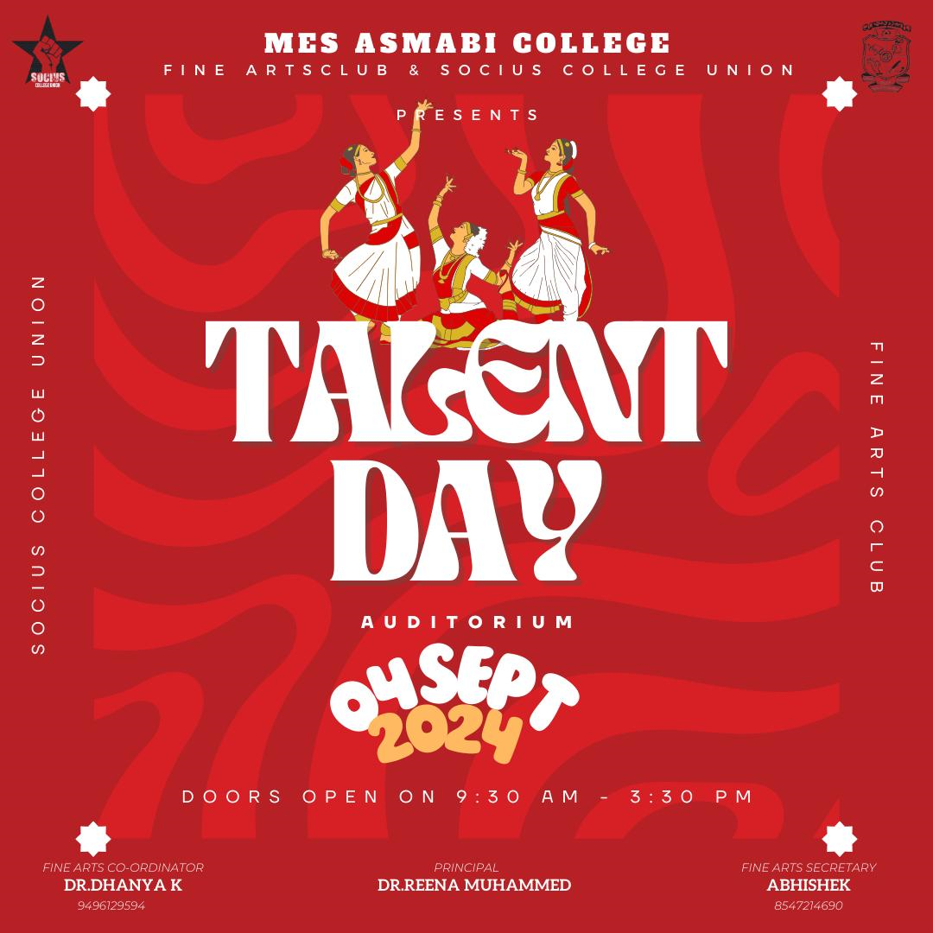
The event was formally inaugurated by Dr. Reena Mohammed, who highlighted the significance of artistic endeavors in personal and academic growth. Her inspiring words encouraged the students to explore their creative potential. The gathering was warmly welcomed by Dr. Dhanya K, the Fine Arts Coordinator, who expressed her enthusiasm for nurturing fresh talent and promoting a culture of artistic appreciation within the college.
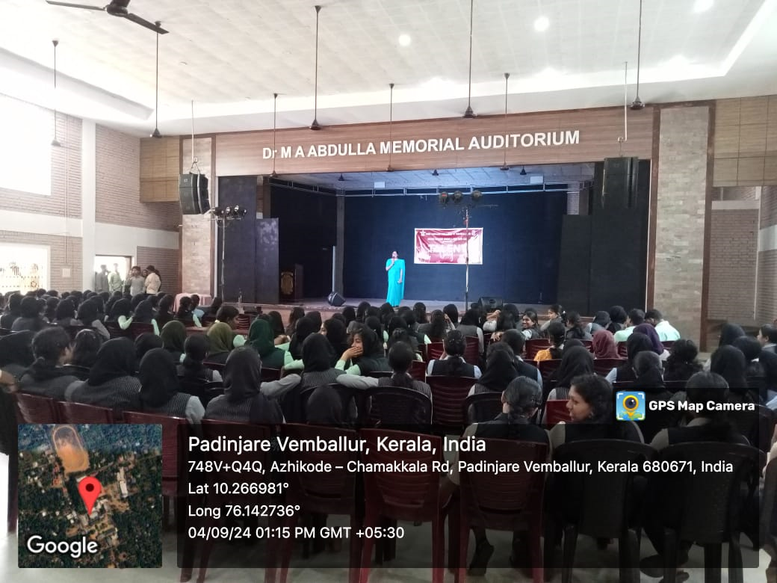
The program featured a variety of performances and displays, including music, dance, painting, poetry, and drama, reflecting the diverse artistic abilities of the participants. The audience was captivated by the enthusiastic performances and outstanding creativity exhibited by the students.
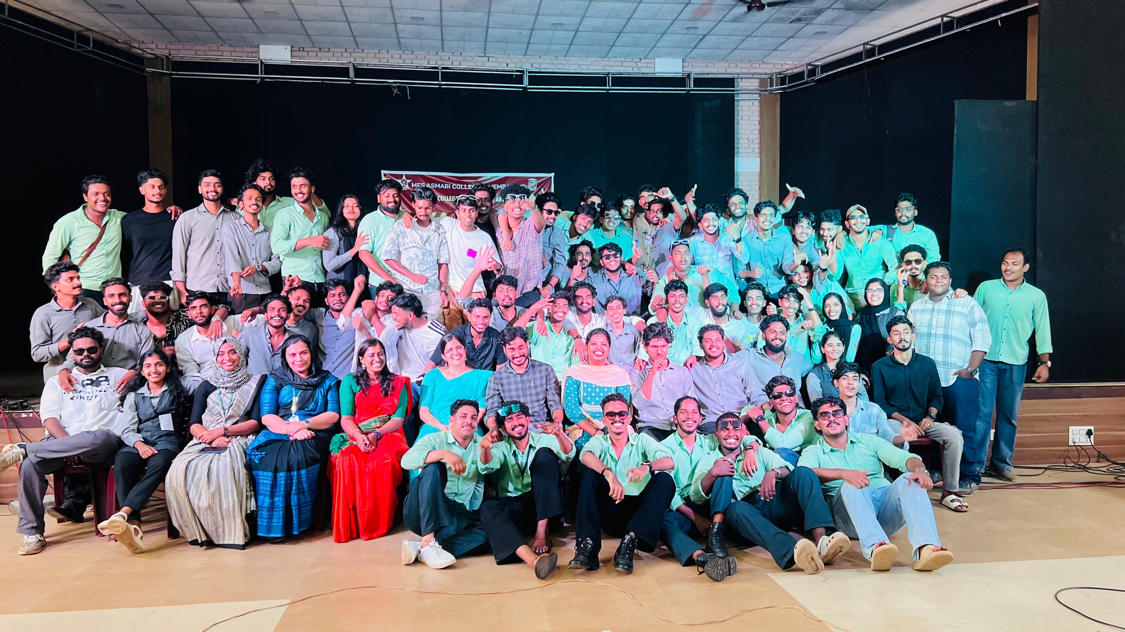
The event concluded on a high note, leaving a lasting impression on both the participants and the spectators. The Fine Arts Club extended its gratitude to the faculty, students, and organizers who contributed to making Talent Day a grand success. The program not only provided a stage for first-year students to shine but also strengthened the spirit of artistic collaboration within the college community.

