MES ASMABI COLLEG, P.VEMBALLUR
FINE ARTS CLUB
International Music Day Observation
21/06/2024
MES Asmabi College celebrated International Music Day with great enthusiasm and fervor on June 21, 2024. The program was inaugurated by Dr. Reena Mohammed, the esteemed Principal of the college, marking the commencement of a day filled with musical delights and cultural harmony. Dr. Dhanya K, the Fine Arts Coordinator of the college, extended a warm welcome to the gathering, emphasizing the importance of music in bringing people together and enriching cultural diversity. Her opening remarks set the tone for a day dedicated to the universal language of music.
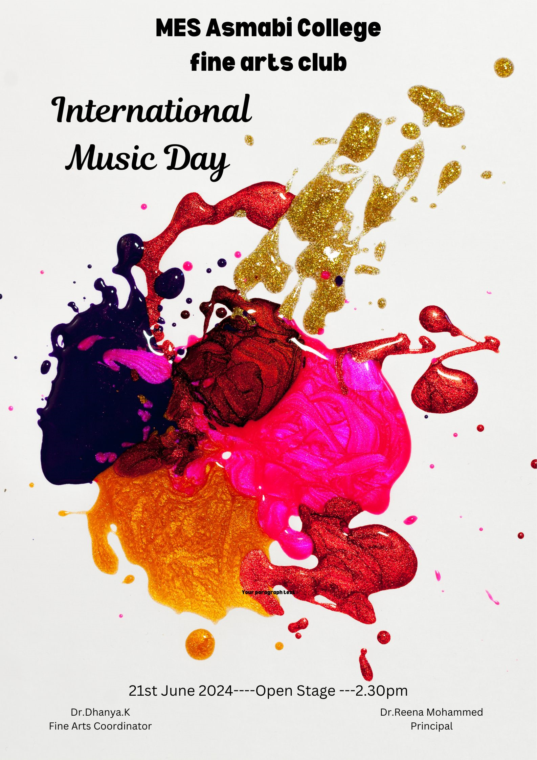

.
Dr. Reena Mohammed, Principal address during the inauguration, spoke eloquently about the significance of music as a universal language that fosters harmony and understanding among people from different backgrounds. He commended the organizers and participants for their efforts in making the International Music Day celebration a resounding success.
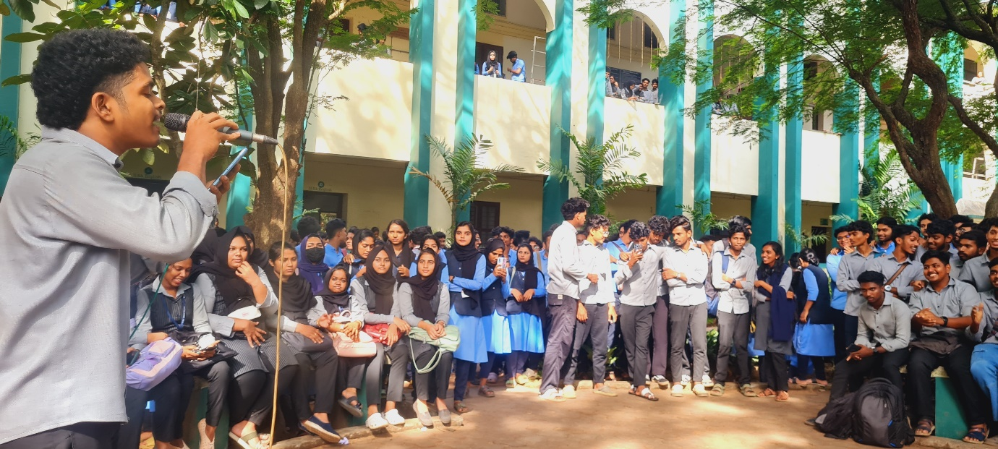
Music Day observation on 21/06/2024

