MES ASMABI COLLEGE, P.VEMBALLUR
FINE ARTS CLUB
FINE ARTS DAY CELEBRATION
13/01/2025 to 16/01/2025
The Fine Arts Club of MES Asmabi College successfully organized Fine Arts Day-SAFDAR from 13th January 2025 to 16th January 2025, providing a vibrant platform for students to showcase their artistic and creative talents. The event was structured to include off-stage competitions on the first two days, followed by on-stage performances, making it an inclusive celebration of fine arts.
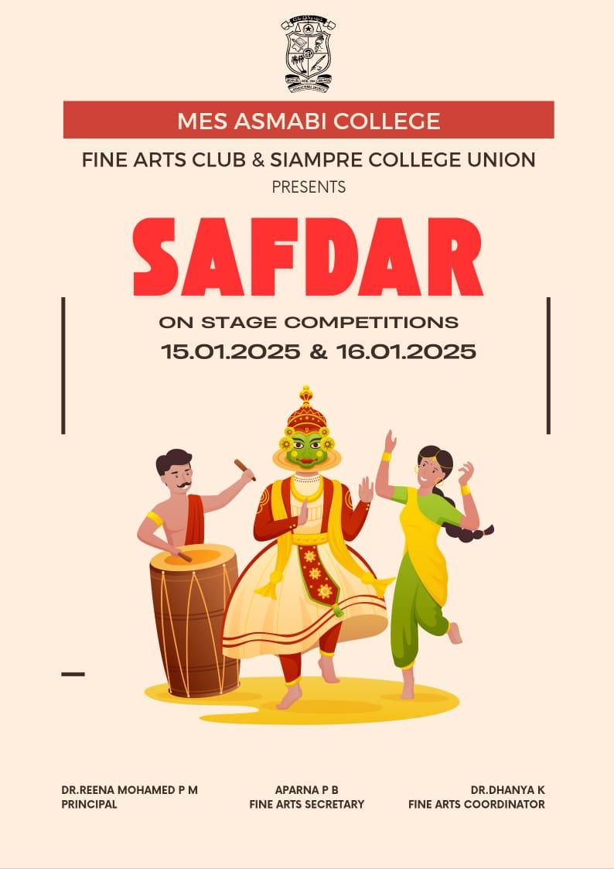
The program was formally inaugurated by Dr. Reena Mohammed, who emphasized the importance of artistic expression in holistic education. Her inspiring speech motivated students to actively participate and explore their creative potential. The gathering was warmly welcomed by Dr. Dhanya K, the Fine Arts Coordinator, who expressed her enthusiasm for fostering a culture of artistic appreciation and innovation within the college.
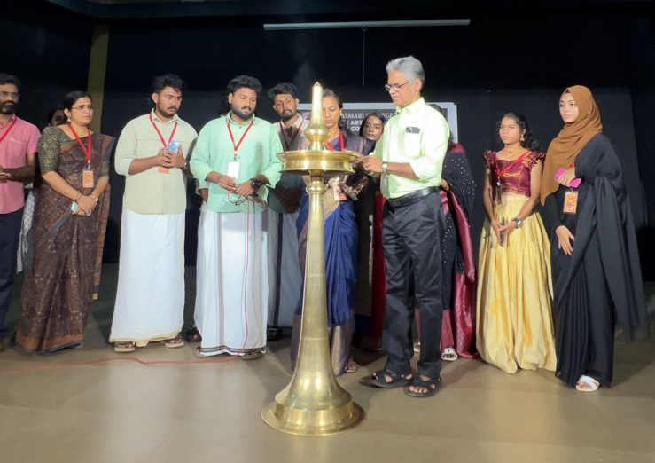
The event featured a diverse range of competitions and performances, including painting, poetry, music, dance, and drama, ensuring a platform for students with varying artistic interests. The off-stage events on the first two days saw enthusiastic participation, setting the stage for the grand on-stage performances that followed.
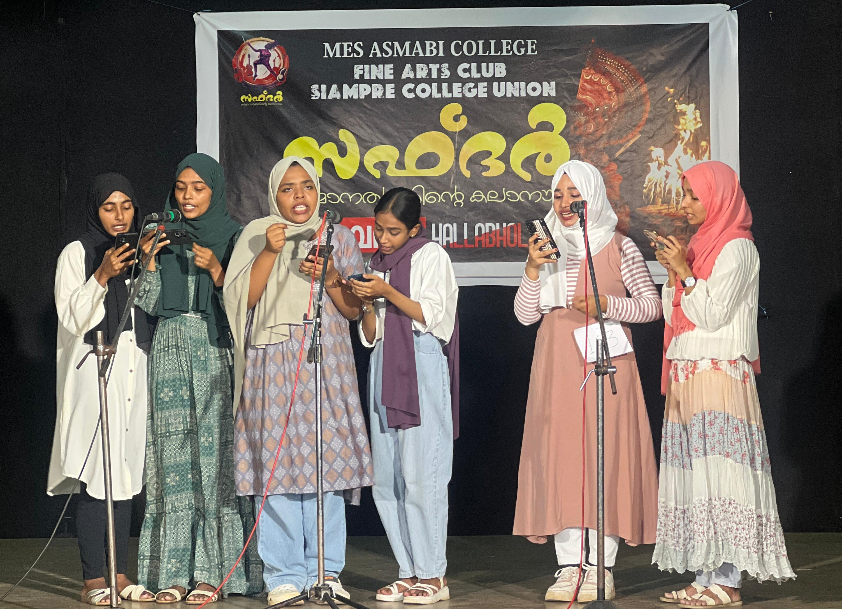

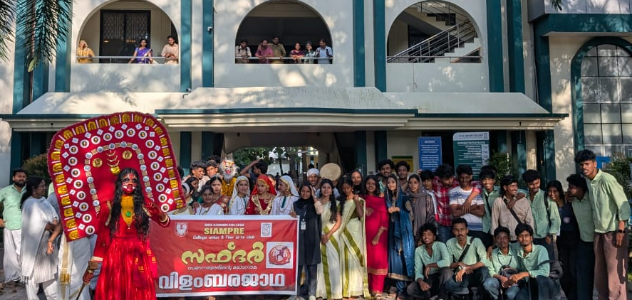
The program concluded on a celebratory note, recognizing outstanding performances and appreciating the efforts of all participants. The Fine Arts Club extended its gratitude to the faculty, students, and organizers who contributed to making Fine Arts Day a resounding success. The event not only provided an opportunity for students to express themselves creatively but also strengthened the bond of artistic collaboration within the college community.

