MES ASMABI COLLEGE, P.VEMBALLUR
FINE ARTS CLUB
PARTICIPATION IN THE LAUNCHING CEREMONY
ASIANET STAR SINGER SEASON 10
The Fine Arts Club members of MES Asmabi College had the prestigious opportunity to participate in the grand launching ceremony of Asianet Star Singer Season 10 on March 3rd, 2025. This remarkable event provided students with a platform to experience the vibrancy of a renowned television reality show and witness the presence of esteemed artists and industry professionals.
The participation of MES Asmabi College students in this event was a moment of pride, as they actively engaged in the celebrations, interacted with renowned singers and performers, and gained invaluable exposure to the world of professional music and entertainment.
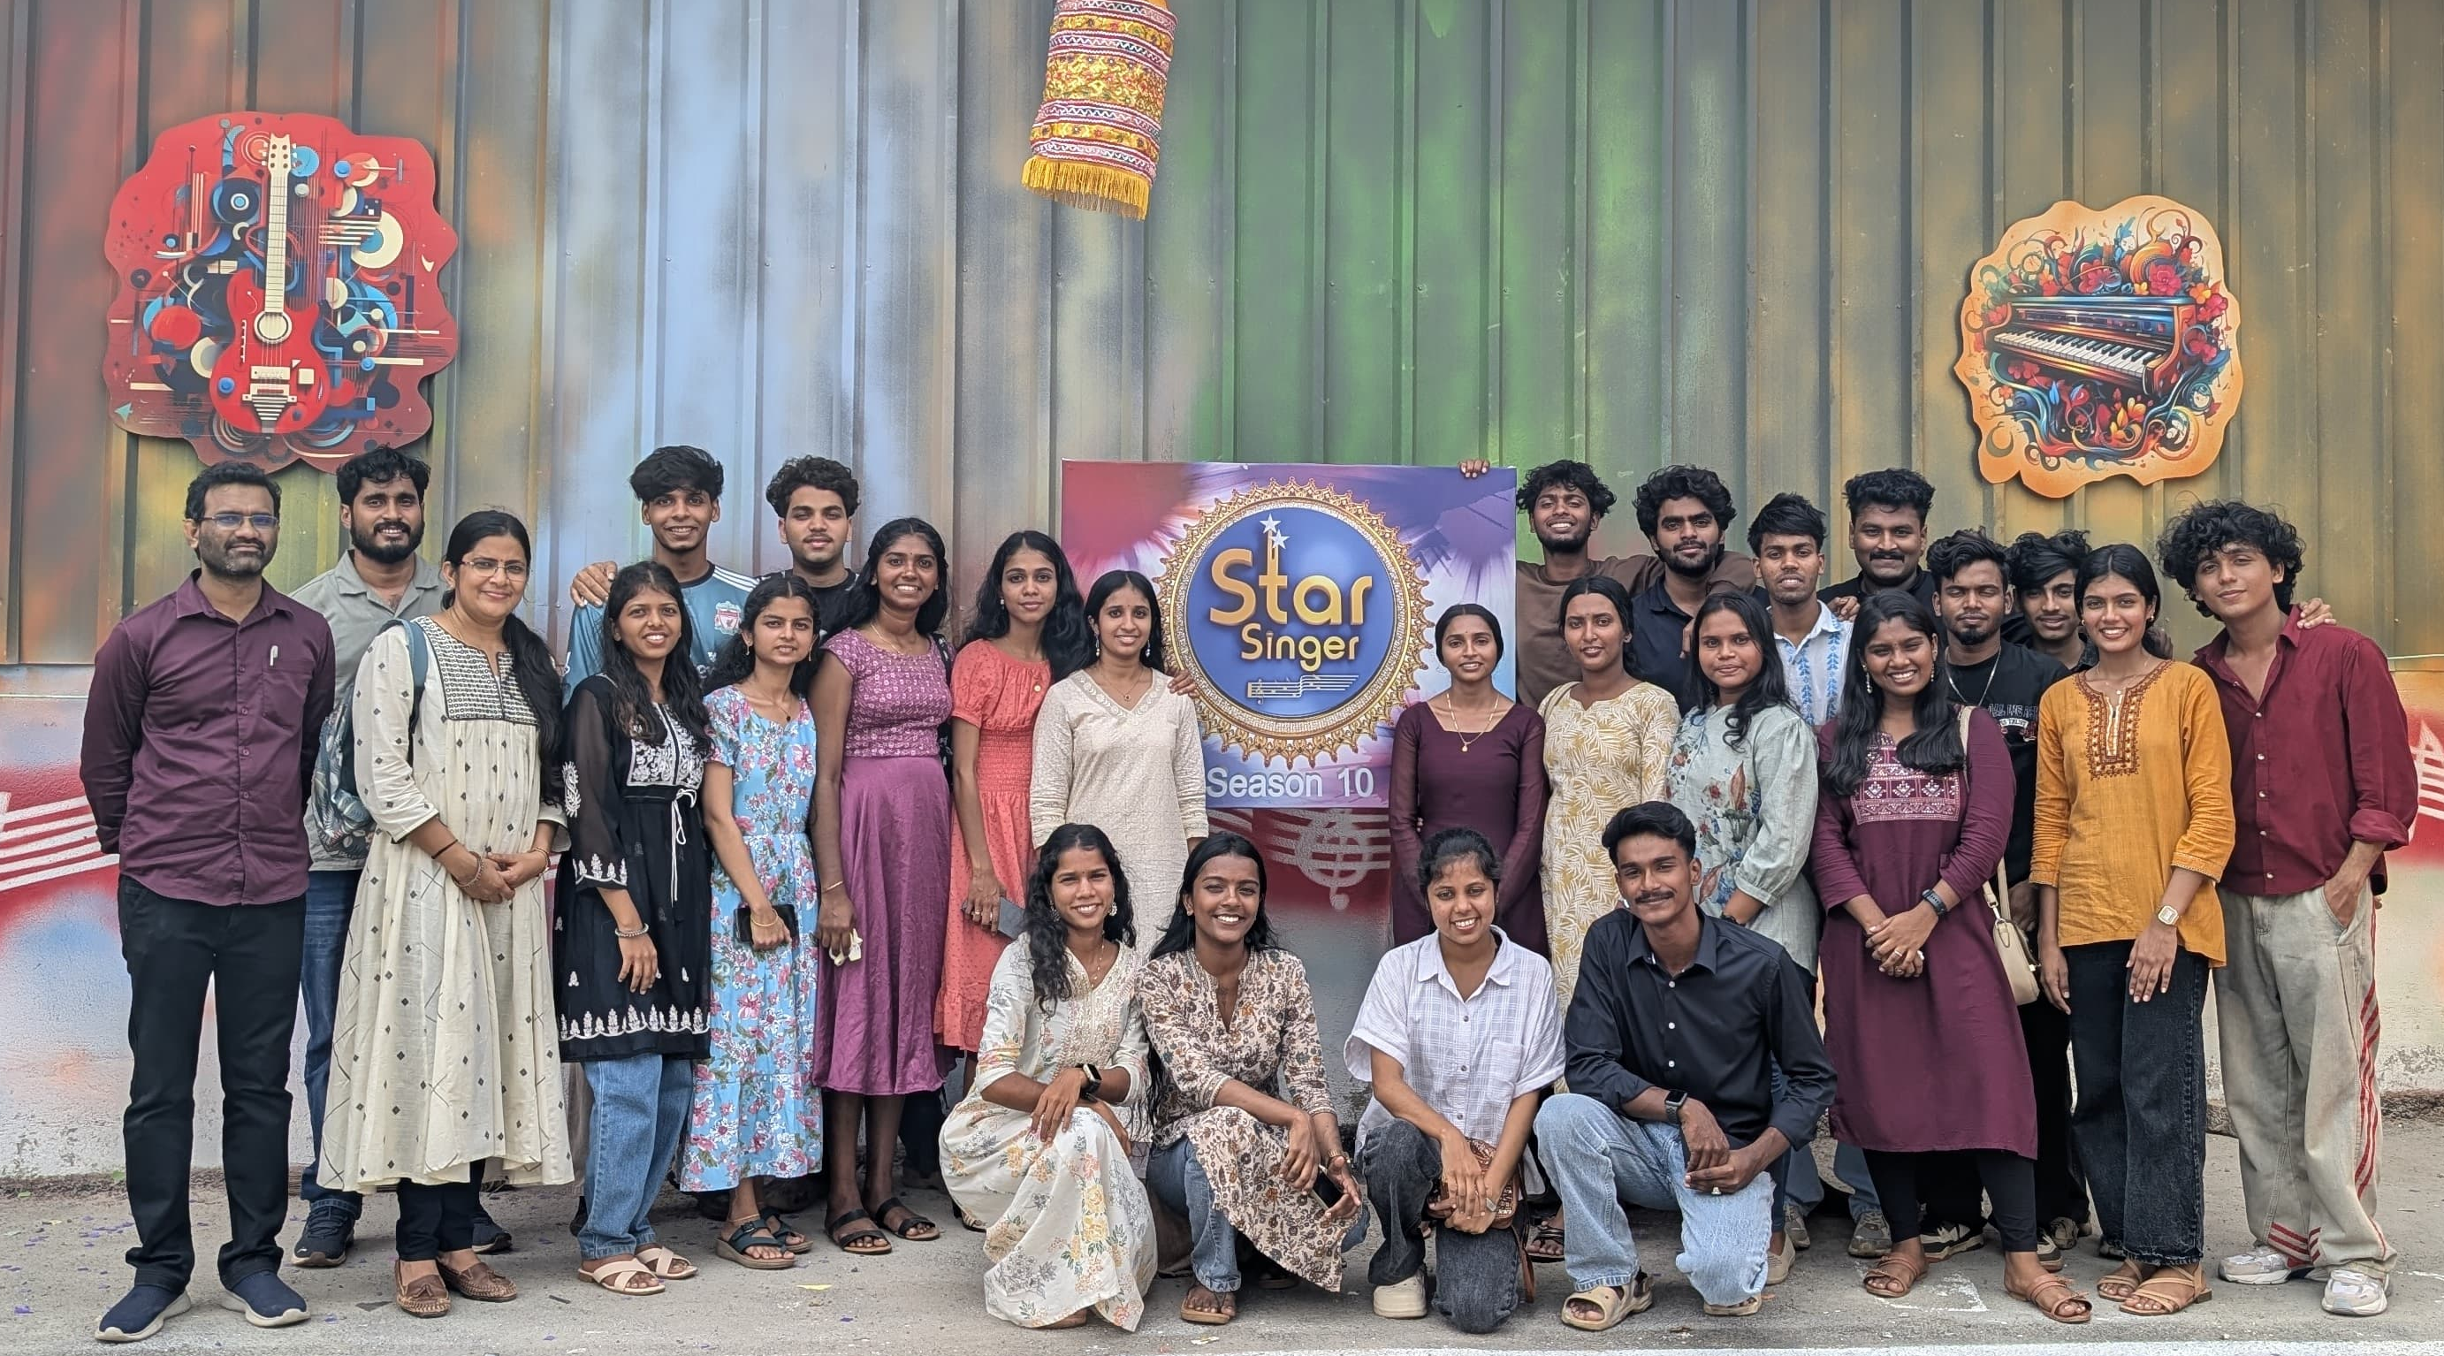
The event served as an inspiring experience for the Fine Arts Club members, enhancing their passion for music and performing arts. Their involvement in such a high-profile event reflects the commitment of the Fine Arts Club to nurturing young talent and providing students with opportunities beyond the academic environment.
The Fine Arts Club extends its gratitude to the organizers of Asianet Star Singer Season 10 for the invitation and to the college administration for their continuous support in encouraging students to explore new artistic avenues.

