MES ASMABI COLLEGE, P. VEMBALLUR
NSS UNITS 53&95

DATE : 20 November 2024
TIME : 1:30PM to 3:30PM
TOPIC : Emergency Life Support Training
VENUE : College auditorium

The National Service Scheme (NSS) unit of MES Asmabi College, in collaboration with the Indian Medical Association (IMA) Kodungallur, successfully organized an Emergency Life Support (ELS) Training Program on 20th November 2024. The primary objective of the program was to equip participants with essential first-aid skills that could save lives during emergencies.
The event was inaugurated by Dr. Reena Mohamed P M, Principal of MES Asmabi College, who emphasized the importance of first-aid knowledge and its practical application in real-life scenarios.
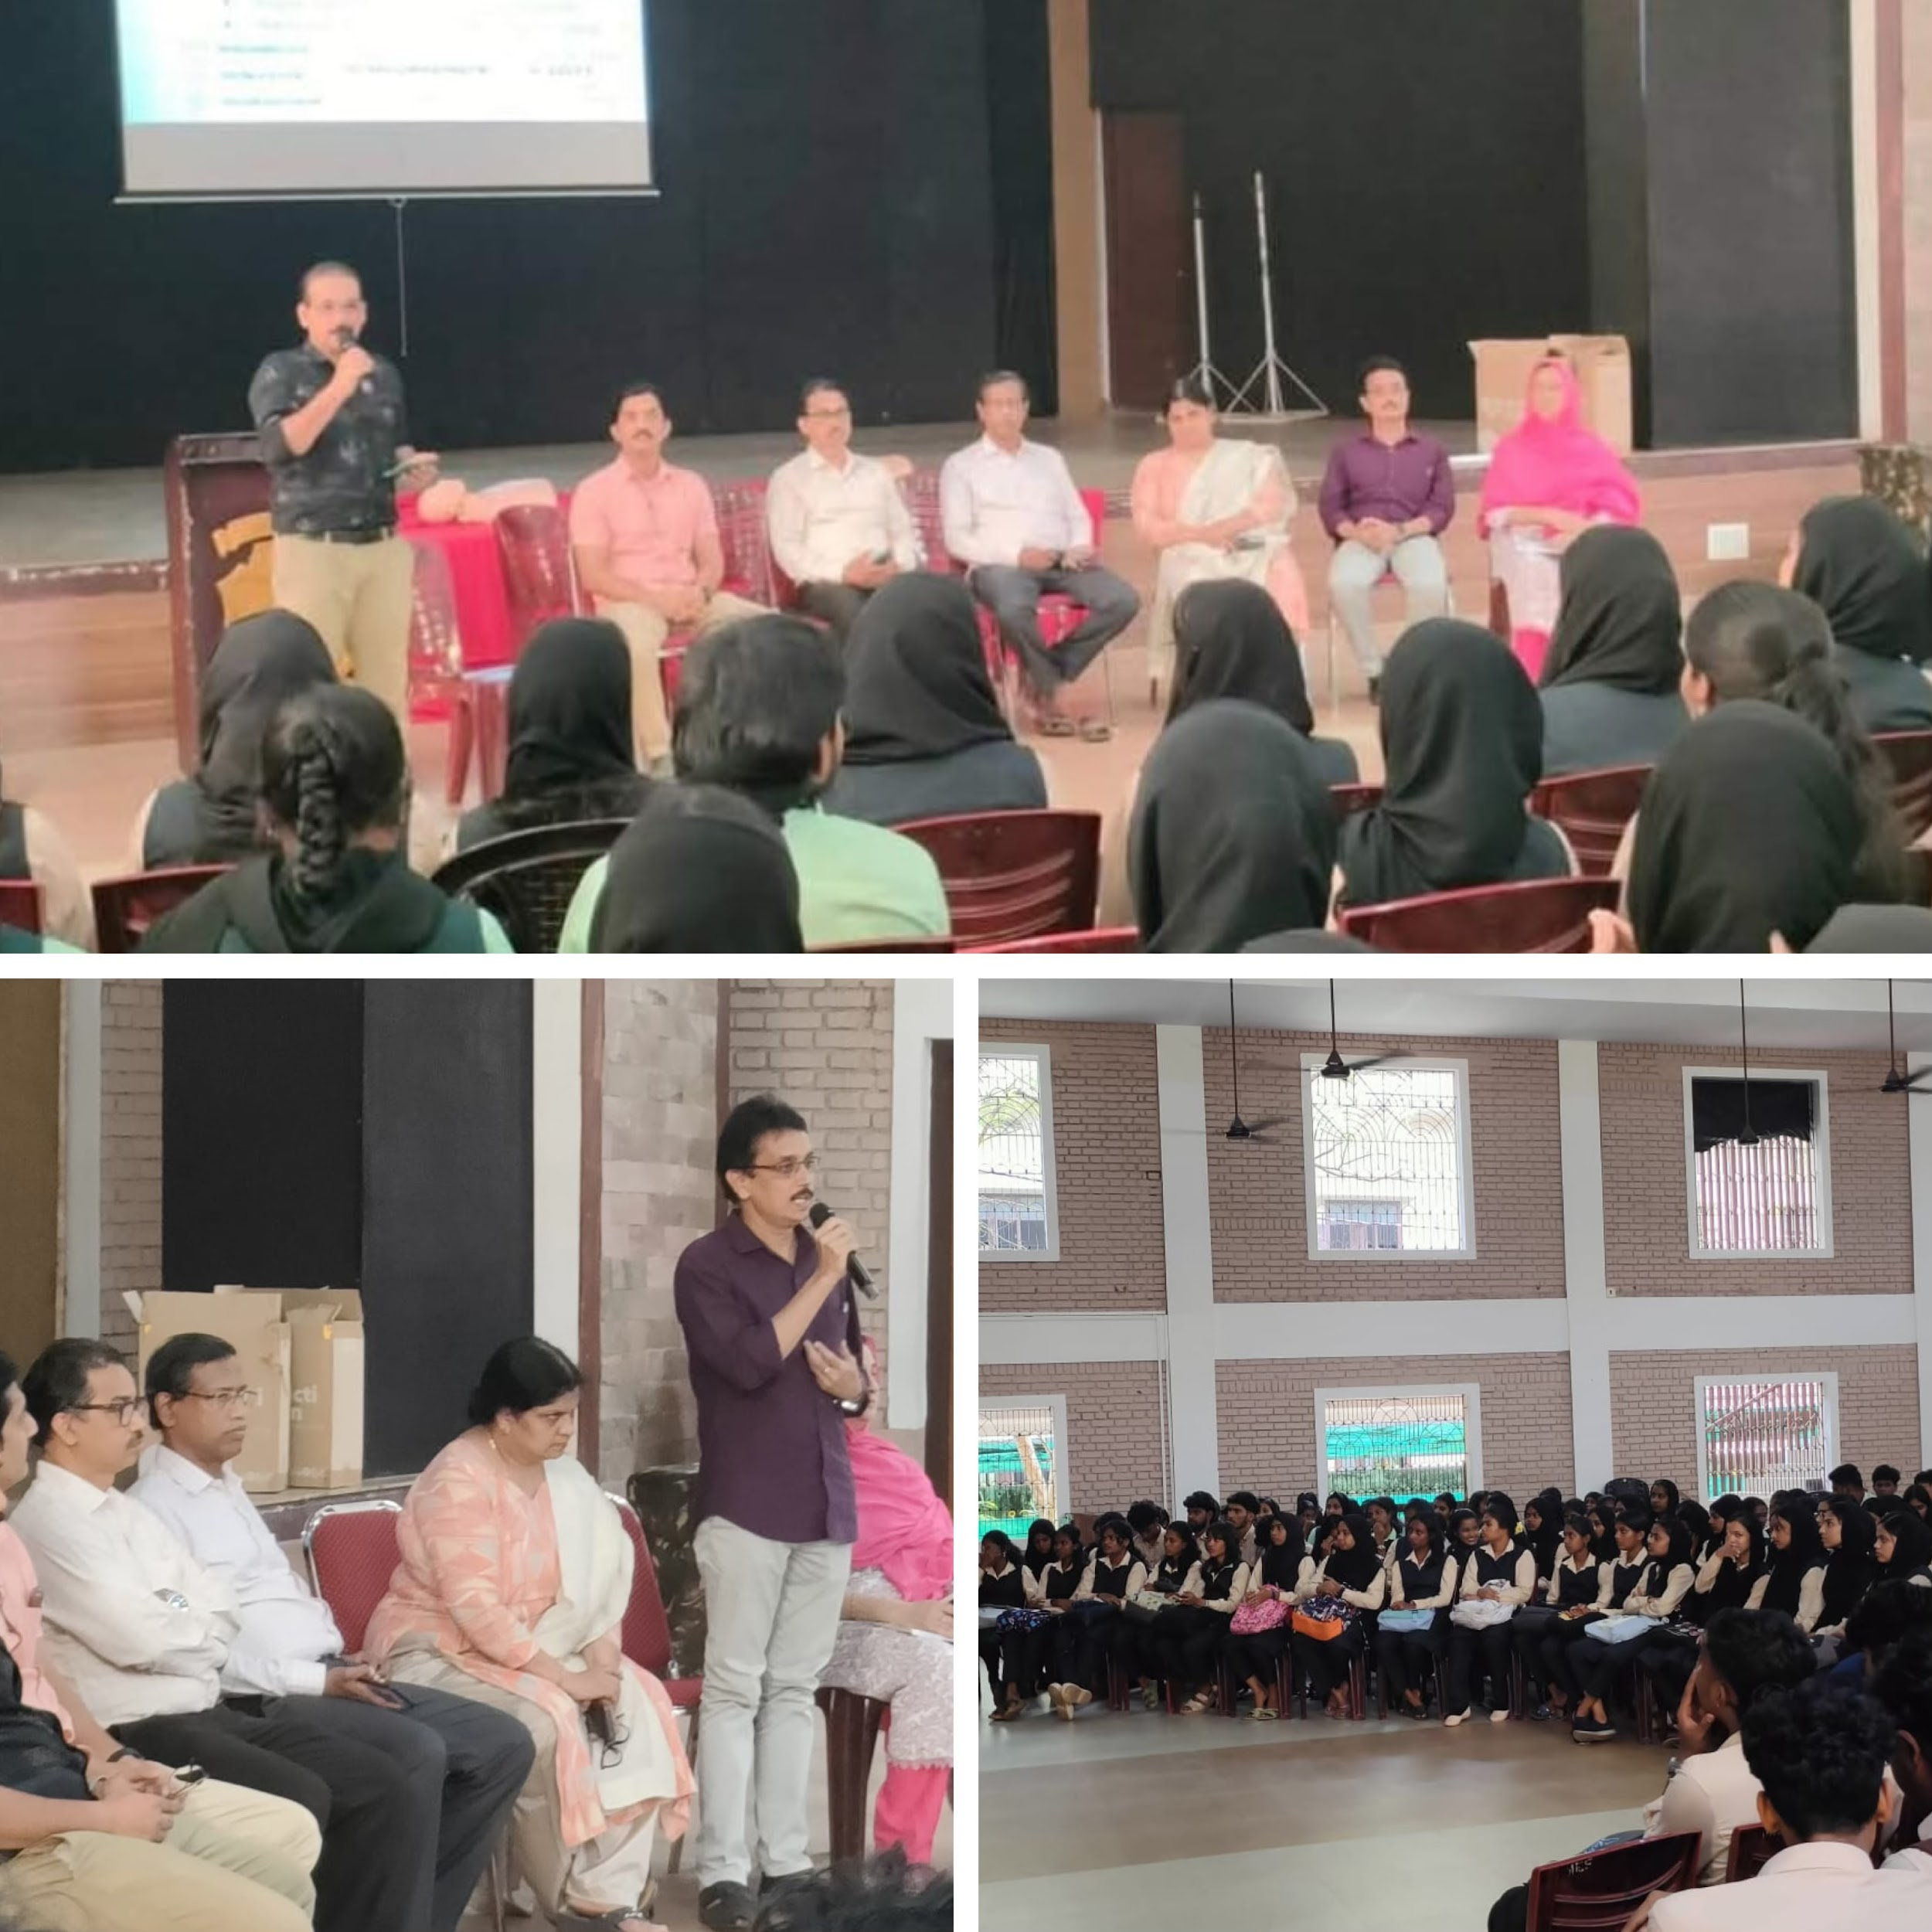
The training session was conducted by Dr. Ajay P G, an Anesthesiologist at AR Hospital, Kodungallur. He provided a comprehensive overview of emergency life support, including the importance of timely first aid in saving lives, practical demonstrations of critical techniques, and guidance on managing medical emergencies effectively. The session was interactive, with participants gaining hands-on experience and learning to act confidently in life-threatening situations.
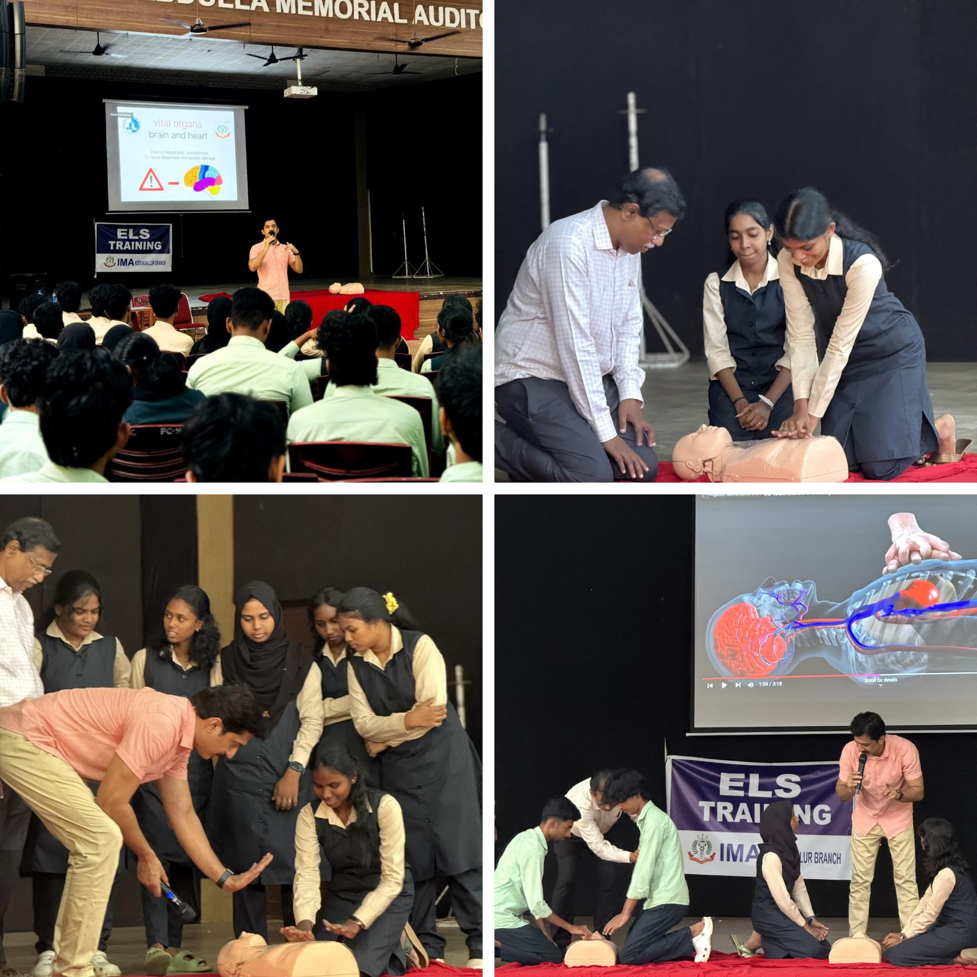
This program was initiated with the aim of providing participants with the knowledge and skills necessary to perform life-saving techniques during emergencies. A significant focus was placed on the practical application of first-aid measures to enhance confidence and readiness in handling critical situations.
The program was a resounding success, with positive feedback from all attendees. It not only equipped the participants with essential life-saving skills but also promoted awareness about the critical role individuals can play in emergency situations.
The NSS unit plans to conduct follow-up sessions and extend similar training to other sections of the college and the local community to create a larger impact.
