Onapudava Distribution Programme
Date: 9th September 2024
Organised by: NSS Units 53 & 95, MES Asmabi College, P. Vemballur
Venue: P. Vemballur Health Care Centre
On 9th September 2024, NSS Units 53 and 95 of MES Asmabi College, P. Vemballur, organised a heartfelt event as part of their community outreach programme. Unit volunteers distributed onapudava to patients under palliative care at the P. Vemballur Health Care Centre. This initiative aimed to spread joy and support among those receiving long-term medical care during the Onam festival. The programme was coordinated by NSS Programme Officers Dr. Sefiya K M and Dr. Basheer P T, who played a vital role in the smooth execution of the event.
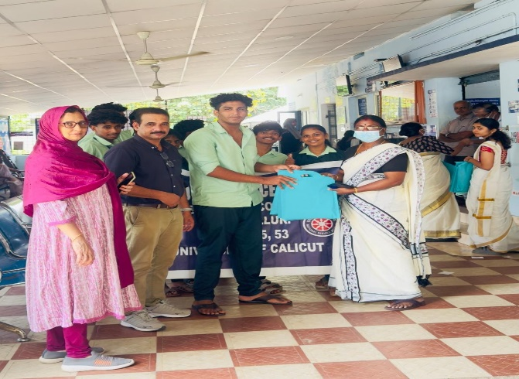 | 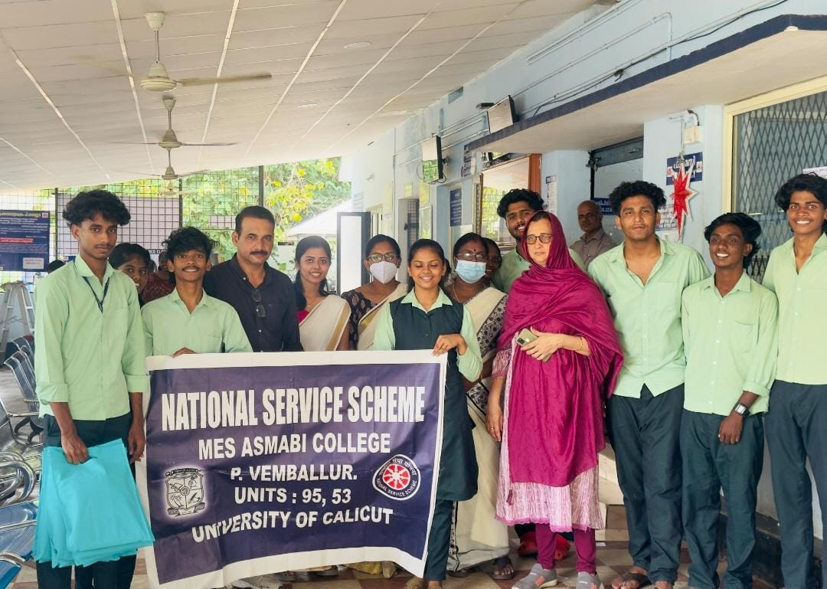
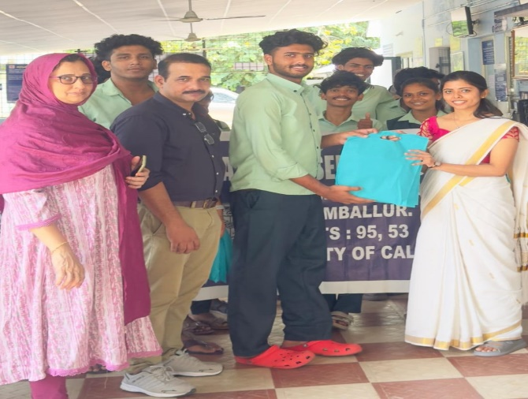 | 