Report on Anti Drugs Awareness Campaign at MES Asmabi College
Date: 18th July 2024
Time: 10:30 AM
Venue: MES Asmabi College, P Vemballur
Organized by: Research Department of Commerce & NSS
Event Overview: The Anti Drugs Awareness Campaign was successfully conducted on the 18th of July, 2024, at MES Asmabi College. The event, aimed at spreading awareness about the dangers of drug abuse and promoting a drug-free lifestyle, saw the active participation of students, faculty members, and invited guests.
Keynote Speaker: The keynote address was delivered by Mr. Jadeer PM, Civil Excise Officer from the Excise Range Office in Irjalakkuda, Thrissur Excise Division, and a Vimukthi Resource Person. Mr. Jadeer shared his extensive knowledge and experience in dealing with drug-related issues and provided valuable insights into the current drug scenario in the region.
Highlights of the Session:
- Introduction to Drug Abuse: Mr. Jadeer started the session by defining drug abuse and its impact on individuals and society. He highlighted the common substances being abused and their adverse effects on health and well-being.
- Legal Framework and Enforcement: He elaborated on the legal measures in place to combat drug abuse, including the role of the Excise Department in enforcing these laws. The importance of adhering to these regulations was emphasized to deter drug-related activities.
- Awareness and Prevention: The session focused on preventive measures, such as community awareness programs, the role of educational institutions in spreading the message, and the importance of early intervention in preventing drug addiction.
- Role of Students and Community: Mr. Jadeer encouraged students to be vigilant and proactive in their communities. He stressed the significance of peer support and community involvement in creating a drug-free environment.
- Interactive Q&A Session: The talk was followed by an interactive session where students and faculty members had the opportunity to ask questions and share their concerns. Mr. Jadeer addressed each query with detailed responses, providing further clarity on the subject.
Conclusion: The Anti Drugs Awareness Campaign was a resounding success, achieving its goal of educating the college community about the perils of drug abuse and the importance of staying drug-free. The insights shared by Mr. Jadeer PM were invaluable, and his call to action resonated with all attendees.

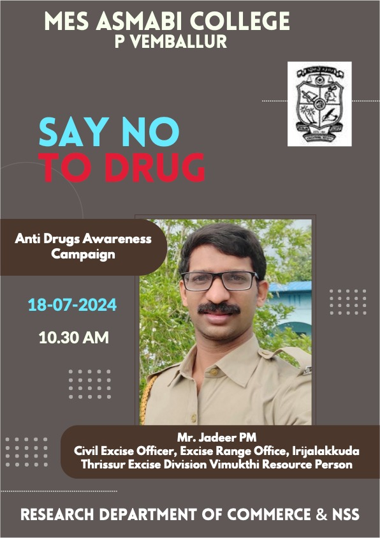
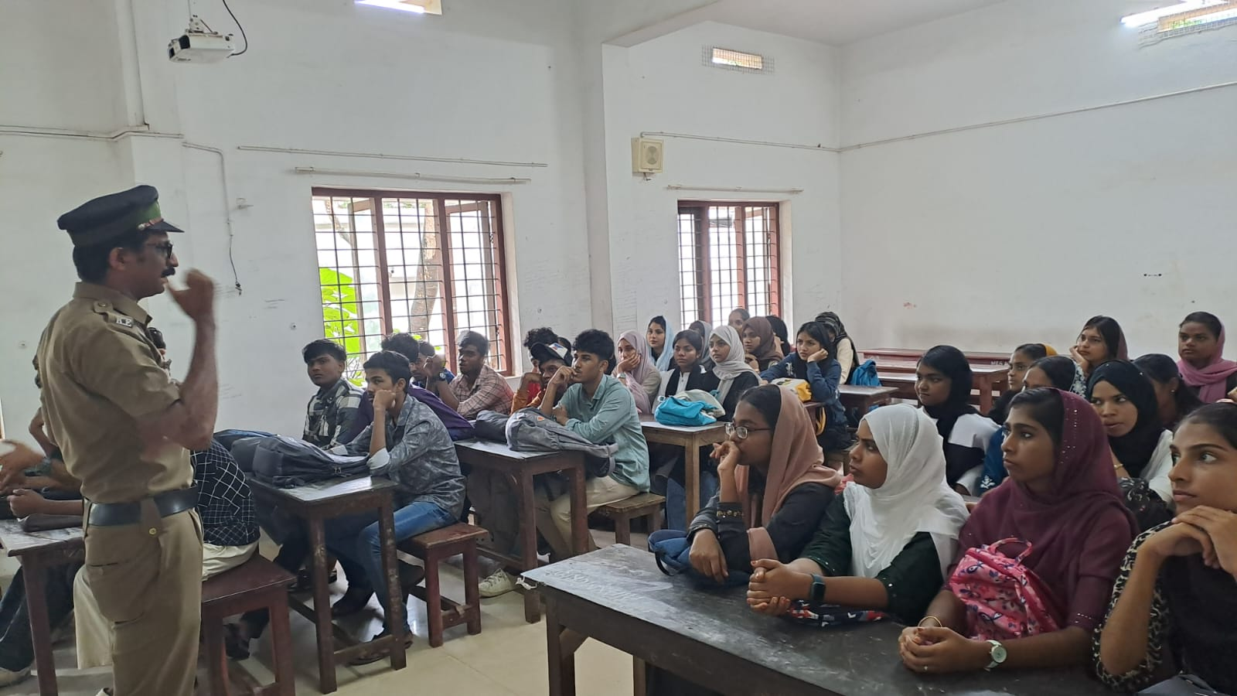 | 