**DEPARTMENT OF MASSCOMMUNICATION AND JOURNALISM**

**MES ASMABI COLLEGE, P.VEMBALLUR**

**REPORT ON HARIYALI CELEBRATION**

Department of Mass communication and Journalism in association with “green campus initiative” observed “HARIYALI” one week celebration as a part of environment day. The series was inaugurated on 6th June by planting saplings in the neighbourhood. The program was coordinated by Sunaina M Nazar, assisted by two other faculties Najma Nazeer and Sumayya K I of the department. Thirty-four students from the department was part of the 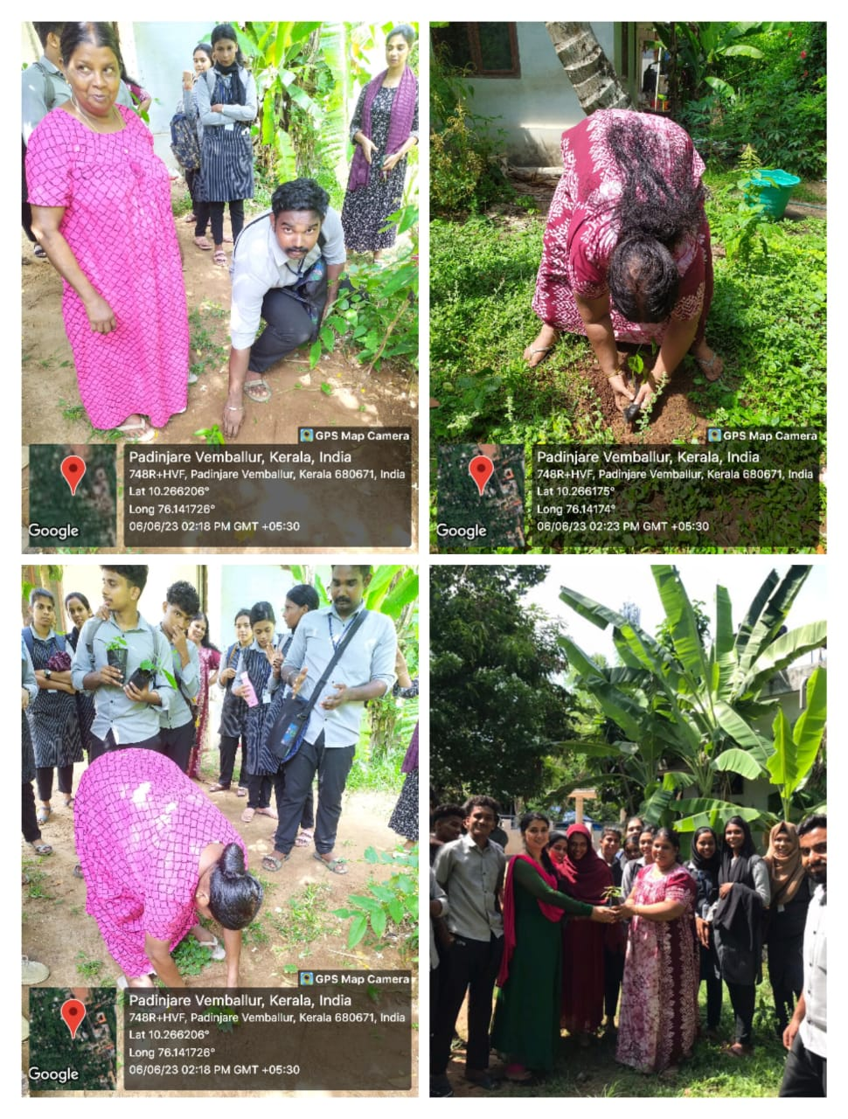 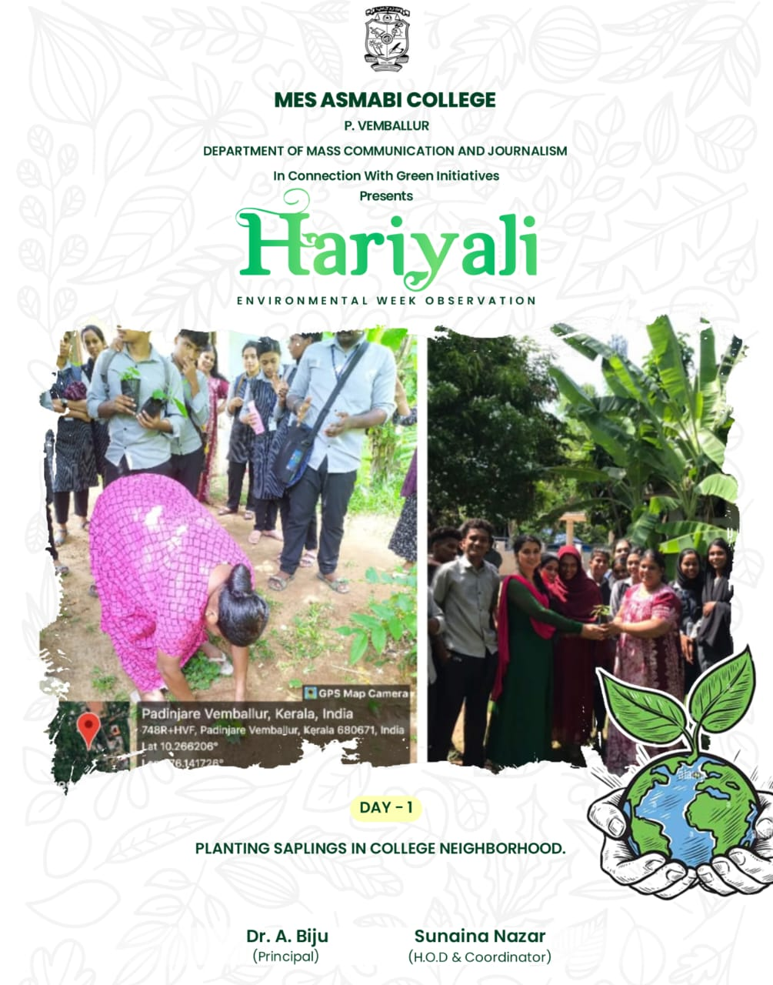

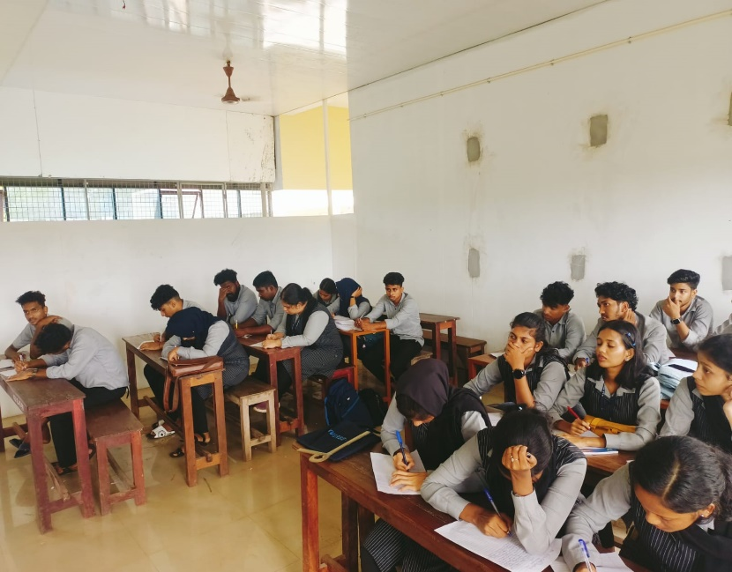

On the second day that is on 7th of June, ESSAY WRITING COMPETITION on the topic was ROLE OF MEDIA IN ADDRESSING ENVIRONMENTAL ISSUES was held. Arjun,moushmi,fathima secured first,second and third positions respectively

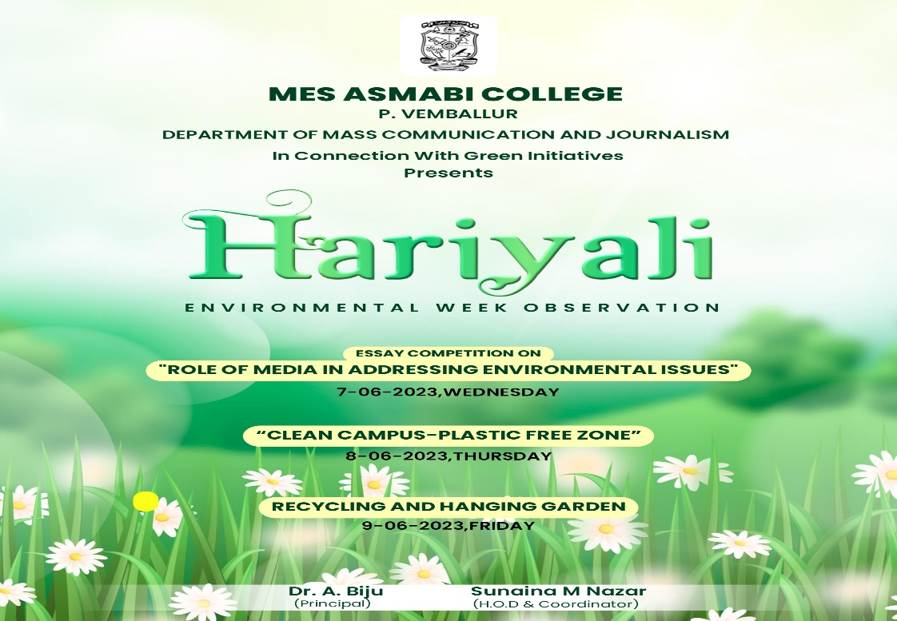

On the third day -THURSDAY (8/6/23)-students focused on cleaning campus making it plastic free zone and also bottle collections were done with the idea REUSE AND CONSERVE

­­­­­­­­­­­­­­­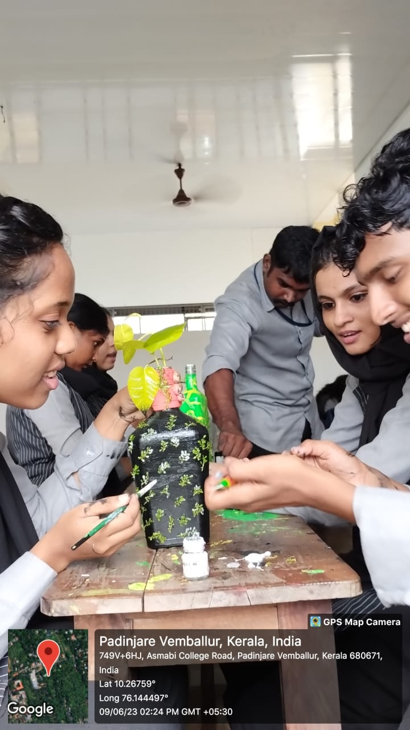 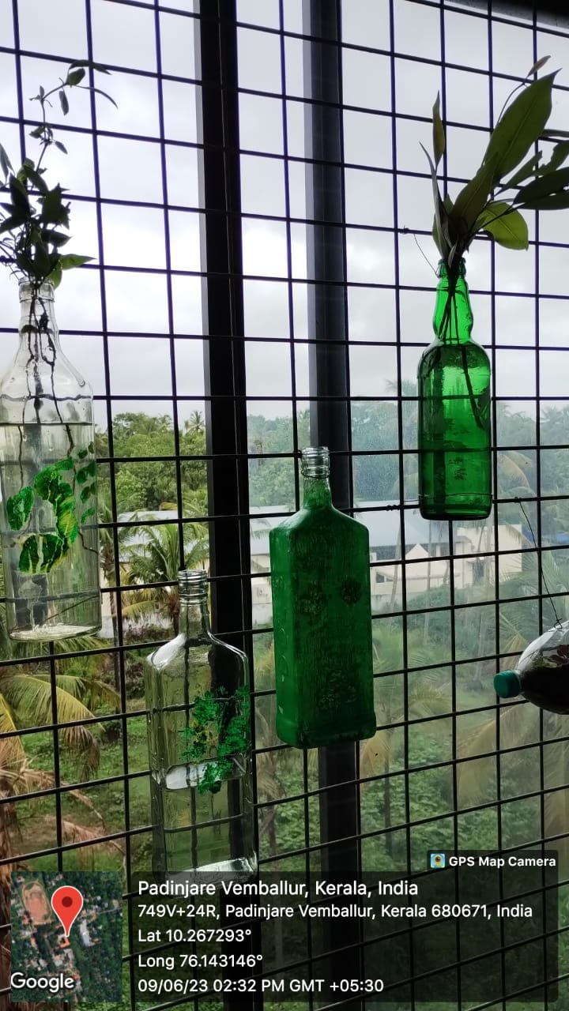

On fourth day- FRIDAY (9/6/23)-collected bottles were painted promoting bottle painting and were used for making hanging garden and was arranged in the classes. Though majority was in the midst of university exam the event turned out to be successful.

