**RESEARCH AND PG DEPARTMENT OF ENGLISH**

**ORIENTATION PROGRAMME FOR I UG ENGLISH 2023-24 ADMISSIONS**

**Title of the program** : ORIENTATION PROGRAMME FOR I UG ENGLISH STUDENTS 2023 ADMISSIONS

**Date of the program** : 05 OCT 2023

**Coordinator** : VEENALEKSHMI UR

**No. Of Participants** : 41

**Objectives of the Program** :

* Introduce students to the ‘what’, ‘why’ and ‘how’ of literature.
* Equip students with skills that will help them to navigate the curriculum with ease and precision

**Report of the program** : An Orientation Programme was organized by Research and PG Department of English for I year English Students on 05 Oct 2023. Dr Sijo Varghese C, Associate Profeesor, Sri C Achuth Menon Govt College, Kuttanellur, was the resource person of the programme. The focus of the session was to acquaint students to the ‘what’, ‘why’ and ‘how’ of literature.

Veenalekshmi UR, I BA English Tutor welcomed the gathering.

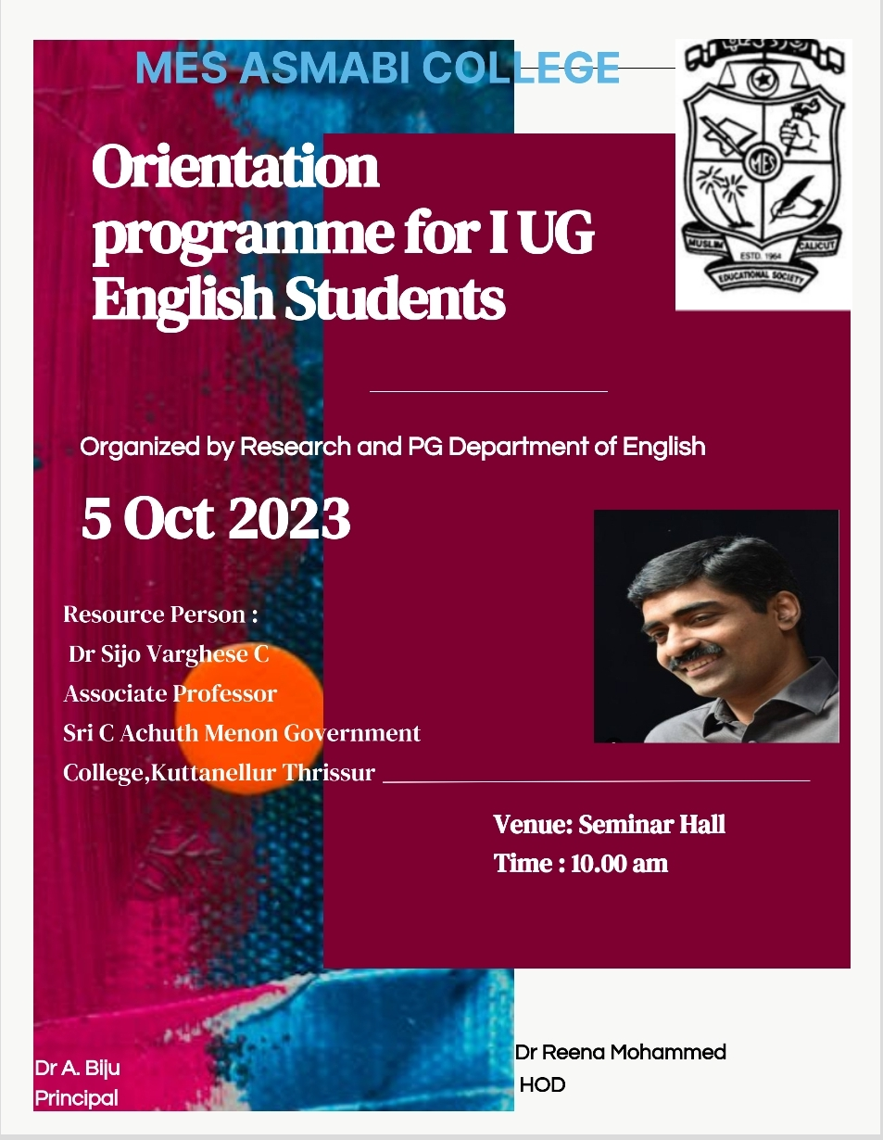

**BROCHURE OF THE PROGRAMME**

The session was interactive, divided into different activities and games. Brain Gym activity, vocabulary building games, ‘out of the box’ games made the session collaborative. The resource person, in the course of the orientation programme, stressed on the importance of building a rich vocabulary and the tasks that the students can engage in to construct a strong vocabulary.

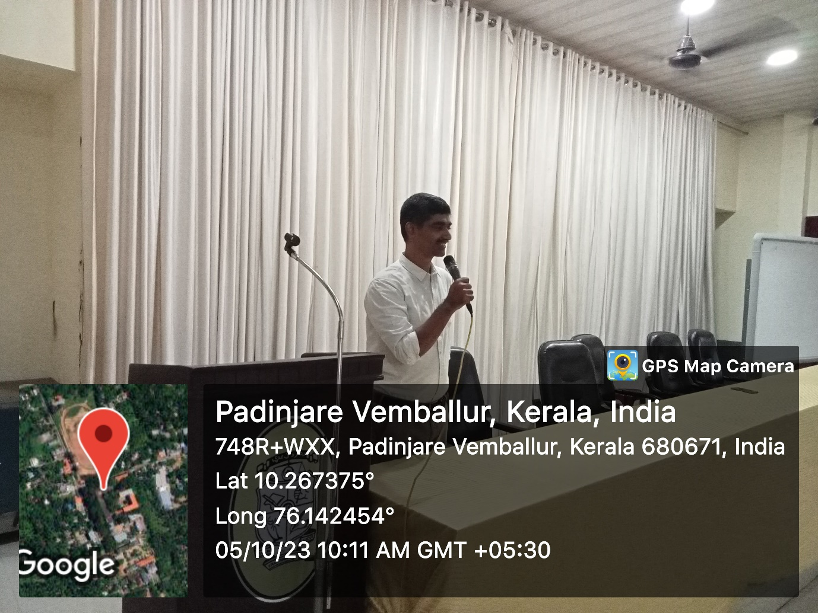

**Resource Person Dr Sijo Varghese addressing students**

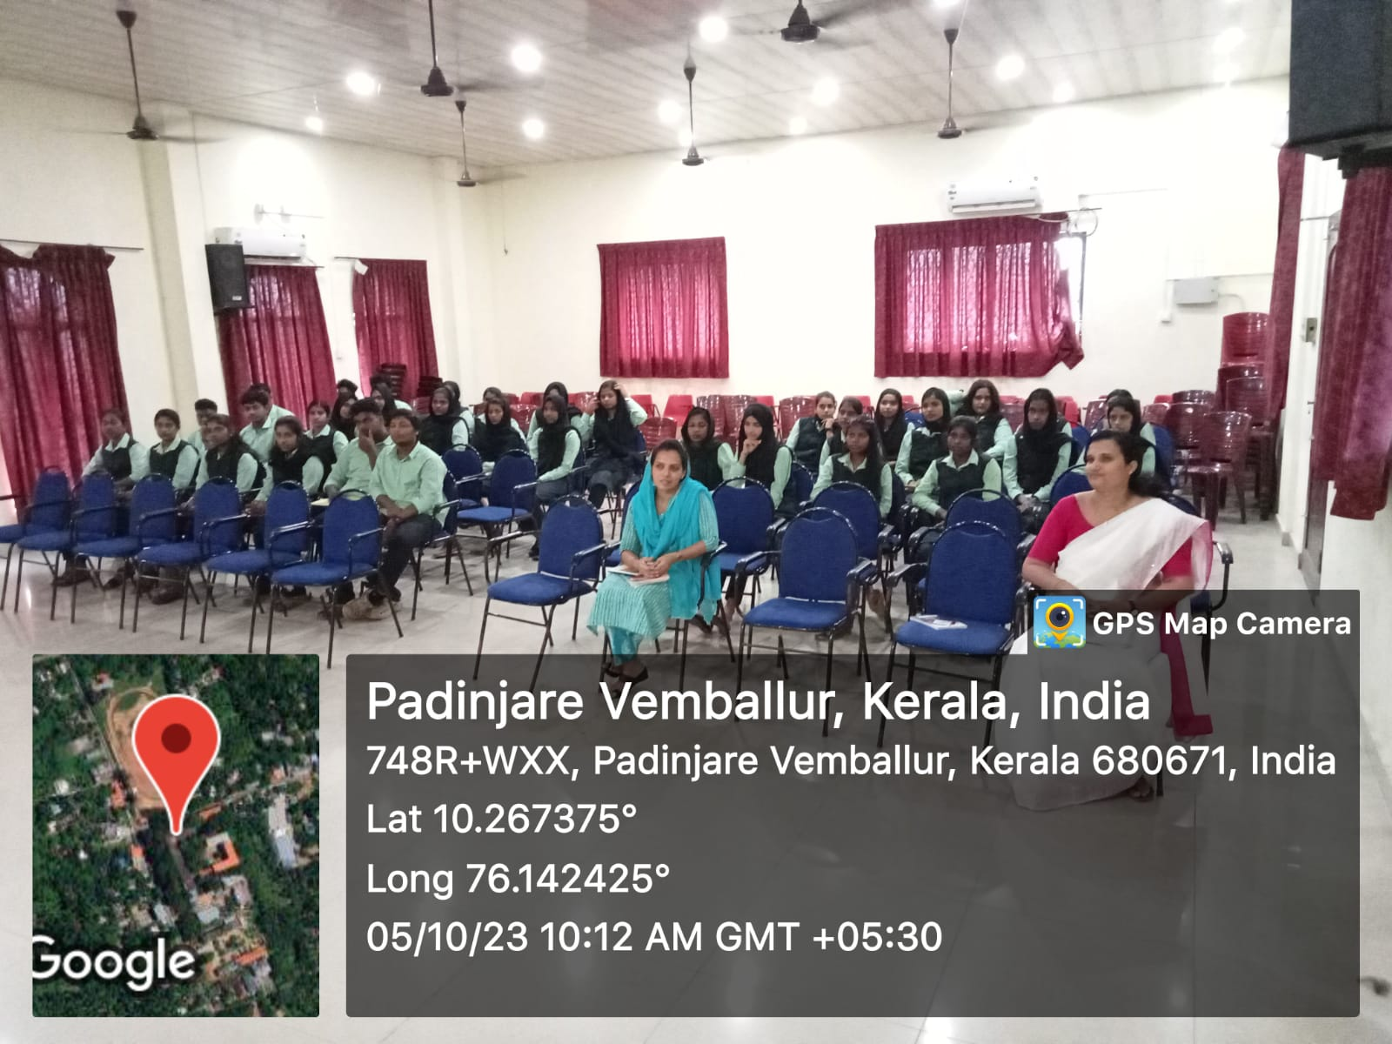

**Student Participation**

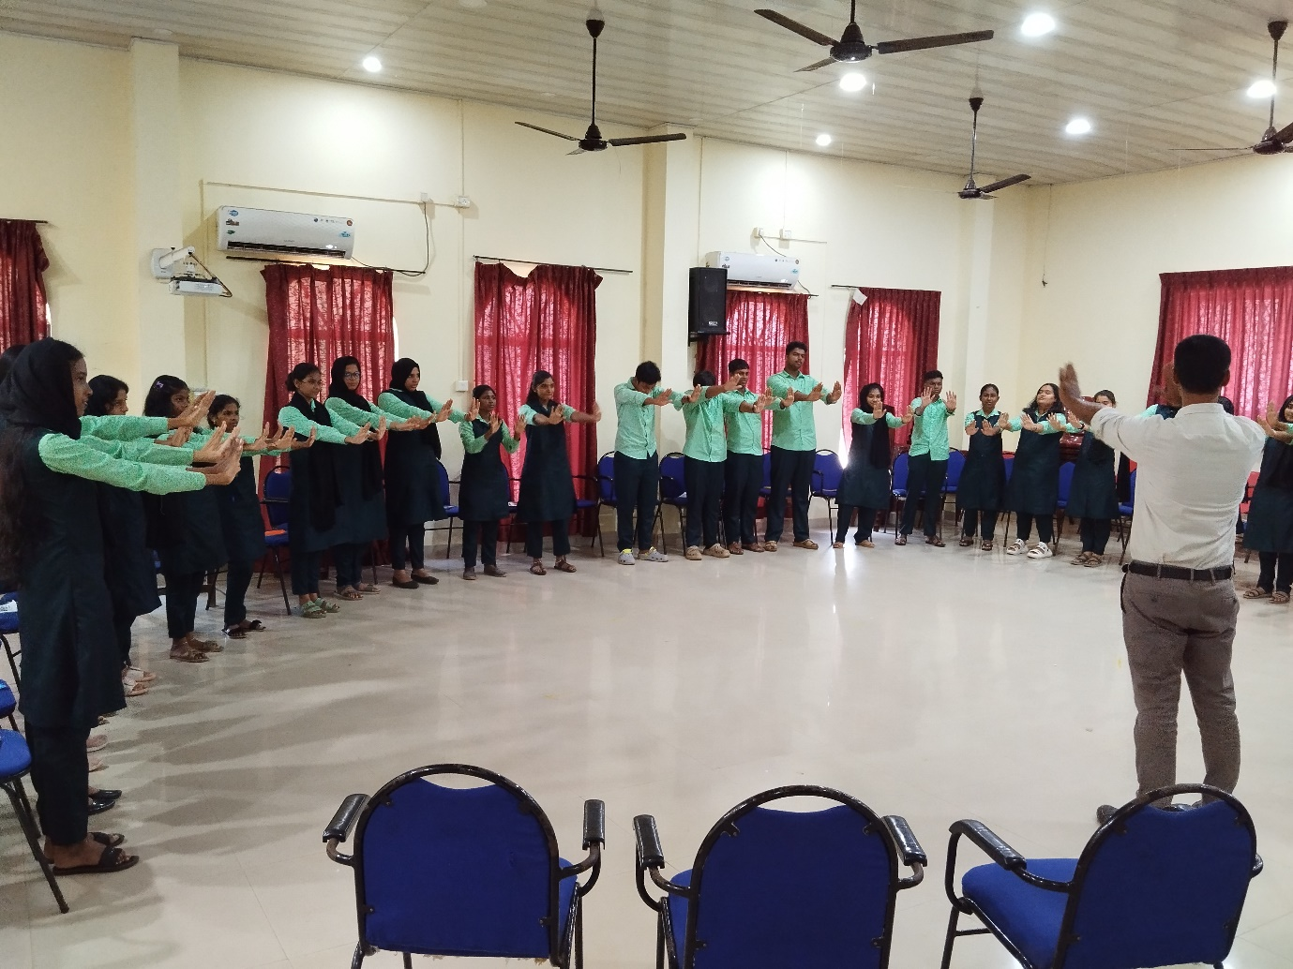

**Activity Oriented Session**

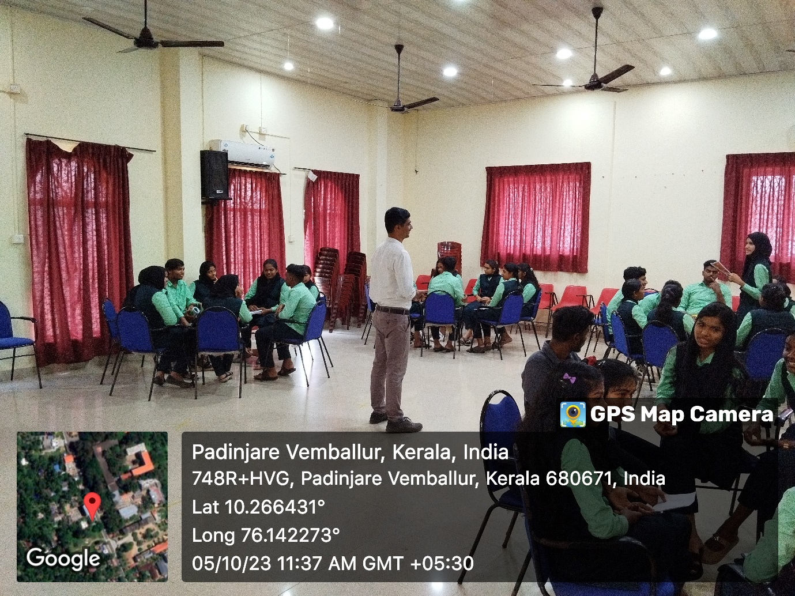

**Students engaged in vocabulary building activity**

The following tasks were assigned to students at the end of the session

1. Open a notebook to regularly write book reviews
2. Set a career goal
3. Learn a new word each day

I year student Nadiya Noufal gave feedback of the session. Vote of thanks was proposed by I year student Fathimath Labeeba.

**Outcome of the Program** : The objectives envisioned for the programme have been successfully fulfilled.

**Feedback** : Students recorded that the session helped them to get acquainted with essential skills that a language learner must nurture over the years of learning.

**LIST OF PARTICIPANTS**

|  |  |  |
| --- | --- | --- |
| **SL NO** | **NAME OF STUDENT** | **SIGNATURE** |
| 1 | FADHIYA KF |  |
| 2 | FASEEHU SHAHANA |  |
| 3 | RISLA NESRIN |  |
| 4 | SHAHANAS CA |  |
| 5 | ABEENA A |  |
| 6 | ABIJITH CHANDRAN |  |
| 7 | FATHIMA KM |  |
| 8 | GOUTHAM KRISHNA CS |  |
| 9 | HANEENA SULATANA PH |  |
| 10 | HARIKRISHNAN KR |  |
| 11 | KRISHNA BABU |  |
| 12 | MOHAMMED ASLAM |  |
| 13 | MOHAMMED ALIF |  |
| 14 | NADIYA NOUFAL |  |
| 15 | NAISANA EM |  |
| 16 | NAJA FATHIMA PN |  |
| 17 | SHAMMAS CU |  |
| 18 | AASHIYA KS |  |
| 19 | ADHEELA MEHARIN |  |
| 20 | ALFIYA FATIMA |  |
| 21 | AMINA KP |  |
| 22 | ANJALINA PJ |  |
| 23 | APARNA PB |  |
| 24 | ARCHANA ER |  |
| 25 | DUATHANA KS |  |
| 26 | FATHIMATH LABEEBA KM |  |
| 27 | GRIJITH MS |  |
| 28 | HAREEKRISHNAN VG |  |
| 29 | HOUFIYA NASRIN RK |  |
| 30 | IHSAN KI |  |
| 31 | IRFAN SHAHID UP |  |
| 32 | KAVYA PK |  |
| 33 | NIHALA THASNIM PM |  |
| 34 | NIRANJANA CR |  |
| 35 | SAFA THASNEEM MM |  |
| 36 | SAHALAN AYISHA |  |
| 37 | SHAZA FATHIMA K |  |
| 38 | SREELAKSHMI NS |  |
| 39 | TS SIVANJALI PANCHA |  |
| 40 | UNNIMAYA KU |  |
| 41 | HANEEN KM |  |