**Report of Women Development Cell-2020-2021**

In pursuance of the directions issued by the University Grants Commission and Ministry of Human Resource Development, Government of India, the M.E.S Asmabi College has set up the Women Development Cell (WDC). The objective of the WDC is to provide and maintain a dignified, congenial working environment for women employees (including teaching, non-teaching and contractual workers) and students, where they can work, study and explore their potential to the fullest. They can approach the Women Development Cell in case of any grievance.

Objectives

To provide and maintain a dignified congenial working environment for women employees (including teaching, non-teaching and contractual workers) and students where they can work, study and explore their potential to the fullest, the WDC has been constituted at the M.E.S Asmabi College.

To sensitize all members of M.E.S Asmabi College community towards the Supreme Court and statutory mandate prohibiting gender discriminations and sexual harassment at the work place and encourage involvement through academic, cultural and outreach activities such as talks, seminars, workshops, community action, drama, street theatre, poster-making etc.

Women’s Day Observation

On 8th of March 2021 WDC have organized a talk on the menstrual period dilemma in youth which was led by Dr Sangeetha Chenampally, Govt College Kozhikode. Smt Veenalakshmi, joint coordinator, WDC welcomed the gathering. Dr.Asma.V.A, Vice principal inaugurated the programme. Dr Sangeetha Chenampally had reiterated the exclusion of taboo related to the menstrual period in the society and community.

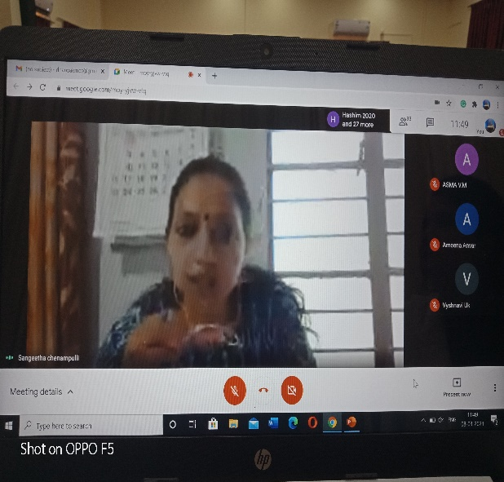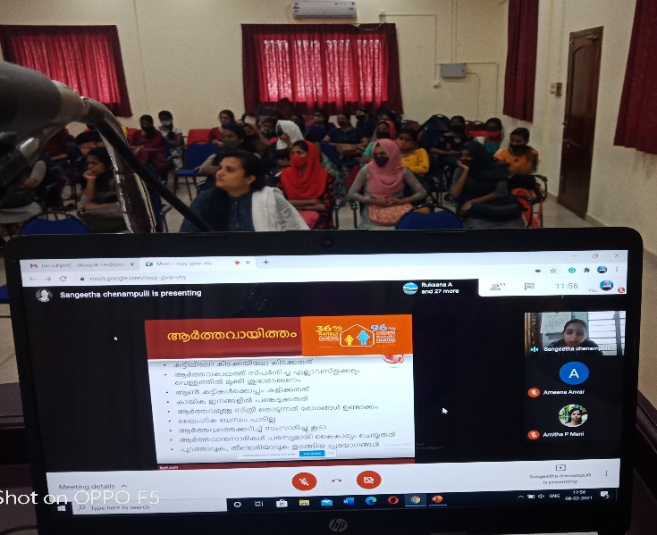

She had urged to see the process as a biological phenomenon rather than considering something related to social stigma. Mrs. Dhanya proposed the vote of thanks