**M.E.S. ASMABI COLLEGE**

## Re-accredited by NAAC with ‘B++’ Grade

**P.Vemballur, P.O. – 680671, Kodungallur, Thrissur Dt.**

**Email:** [**principal.mesasmabi@gmail.com**](mailto:principal.mesasmabi@gmail.com) **Web.**[**www.mesasmabicollege.org**](http://www.mesasmabicollege.org/)

**REPORT ON THE WORKSHOP ON RESEARCH METHODOLOGY IN PSYCHOLOGY**

Date: September 28th , 2018

Venue: MES Asmabi College, P. Vemballur, Department of Psychology

Organized by: Department of Psychology, MES Asmabi College

The Department of Psychology at MES Asmabi College, P. Vemballur, organized a workshop on Research Methodology for final year undergraduate students on September 28th, 2018. The event aimed to equip students with essential skills and knowledge necessary for conducting robust research in the field of psychology.

Ms. Sangeetha P.S, the Head of the Department of Psychology, extended a warm welcome to the participants. She emphasized the importance of research methodology in academic and professional pursuits, setting the tone for an engaging and insightful workshop.

The resource person for the workshop was Dr. Monsy Edward, an Associate Professor from Prajyothi Nikethan College, Thrissur. Dr. Edward brought a wealth of experience and expertise to the session, guiding students through the intricacies of research design, data collection, and analysis. His engaging presentation style and real-world examples resonated well with the attendees.

The coordination of the session was led by Ms. Sangeetha P.S and Aysha, Assistant Professor in the Department of Psychology. Their efforts ensured a smooth and organized flow of the workshop, allowing participants to actively engage with the content.

The workshop concluded with a vibrant discussion on the presented topics, providing students with the opportunity to clarify doubts and deepen their understanding. The active participation reflected the success of the event in fostering a collaborative learning environment.

Overall, the Research Methodology Workshop proved to be a valuable experience for the final year undergraduate students, enhancing their research skills and preparing them for future academic and professional endeavors. The Department of Psychology expressed its gratitude to Dr. Monsy Edward, for his insightful contributions, and to the coordinators, Ms. Sangeetha PS and Ms. Aysha, for their dedication in organizing the workshop.

Programme Brochure:

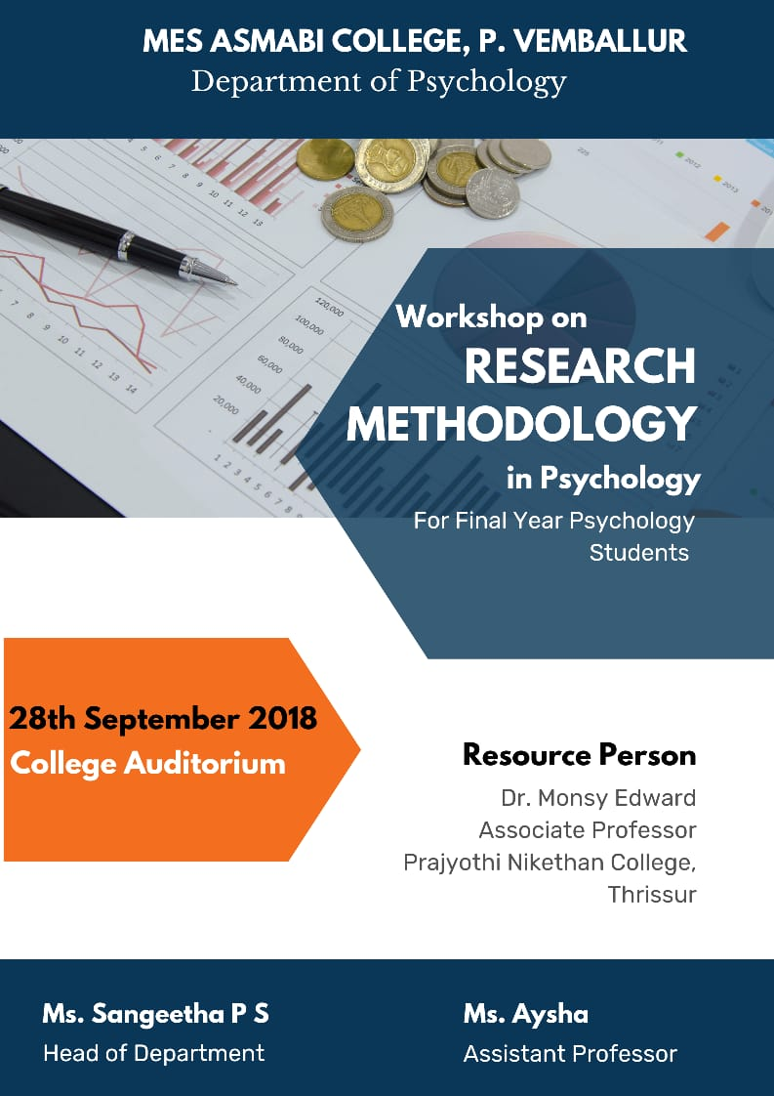

Programme Photographs:

