Student Faculty Exchange Programme & Study Tour
Department of Hindi of MES Asmabi College,P.Vemaballur,Kodungallur in association with Department of Hindi of Central University of Puducherry conducted its second phase of Student Faculty Exchange Program on 5- 8 of March of 2017.
https://www.facebook.com/photo/?fbid=1370594512997960&set=pcb.1370596932997718&__cft__[0]=AZWmjiVCAqFXC-CBp7TcPPq0L2TuetCsJLztzR2BKbMW_UaBTMZbZnMnXyXfgZtDNR-Ljoz_8wn0lUq-49IAs0Mbxj4ZIlZPiKOtaBGRa0vH6Cy8q5WlGw_MBSuPi_2T58KDrUDmar7aoV_zfP28oX50TuYf_tUkcJPthkI0pfx6FTKlbSlKCaHJPDC8rG3xkzU&__tn__=*bH-y-R
Eight students from various Departments of the College ,who learns Hindi as their second language were selected. They prepared papers on cultural diversity of kerala and presented their views at the Department of Hindi of Central University o f Puducherry and actively involved in discussions.Dr.C JayashankarBabu, HOD ,Dept. of Hindi of CUP,Dr Ranjith.M(,Dr.Surya Boss lead the program.After the sessions the students visited various Departments of the University.
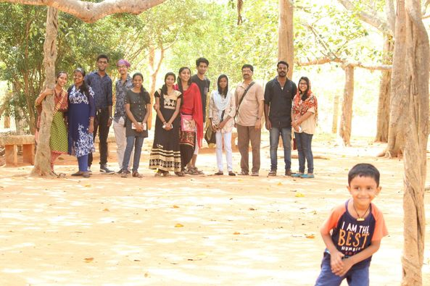
Then the host arranged facilities to visit important places of Puduchery.
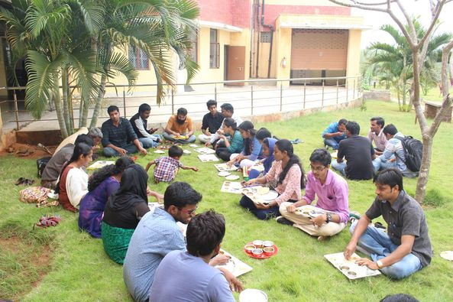
Luncheon meeting with Hindi Department students of Puducherry University.
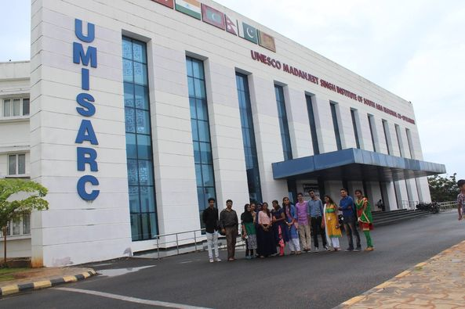
The event was partially sponsored by the Management of the College.Through the program students got clear idea about their future studies.
Dr.Ranjithj.M
08.03.2017

