Gramika social service Programme
Gramika social service Programme organized by dept.of hindi,Arabic, Malayalam, history and physical education dept. In collaboration with Ahalya foundation and edavilang grama panchayath on07.12.2016.Around 200 persons attended the camp and Doctors examined them.Then around 50 persons were advised to undergo cataract operation.
Ahaliya Hospitals arranged needful arrangements and operation was done on 12.12.2016.Later some of them contacted the organizers and conveyed their happiness for the eye camp.
https://www.facebook.com/photo/?fbid=1272762129447866&set=pcb.1272764896114256&__cft__[0]=AZVvZXcHdg0MYufYO8wJObXOOBYdX0AoFTgl2TNXDofhtNmSL5GnTfjyLjN8PZh7ByNOtGYc_0Bg9e_5k7P2FLAkz8paInqrCQYXzUp3cyqGtuZEAspP-TJWD_qeAoQqLJFj2wPMnTmfPQTwC3QS1i0z063qSn_iSsBfusSKpPMtFA&__tn__=*bH-R
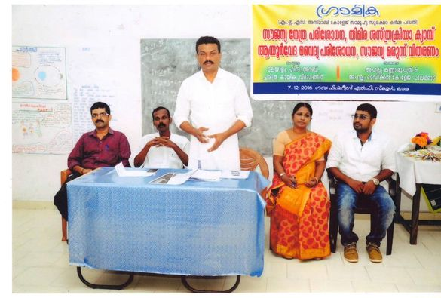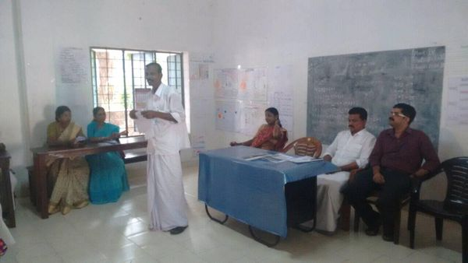

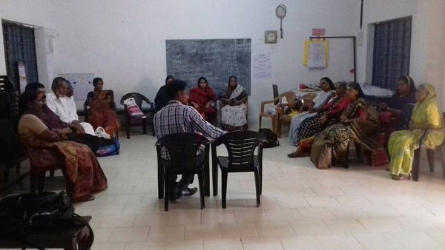
Dr Ranjith .M 07.12.2016

