M.E.S. ASMABI COLLEGE

Re-accredited by NAAC with ‘B++’ Grade
P.Vemballur, P.O. – 680671, Kodungallur, Thrissur Dt.
Email: principal.mesasmabi@gmail.com Web.www.mesasmabicollege.org

REPORT ON RESEARCH METHODOLOGY WEBINAR

Date: October 1, 2020
Time: 11:00 AM - 12:30 PM
Platform: Google Meet
Participants: 31
Organized by: Department of Psychology, MES Asmabi College

Introduction:
The Department of Psychology at MES Asmabi College organized a one-day webinar on Research Methodology for final year students of the Psychology department. The session aimed to provide students with insights into various research methods and their practical applications. The event was held on October 1, 2020, and was conducted through Google Meet. The distinguished resource person for the webinar was Ms. Mohsina Lubaiba, a renowned Child Psychologist at Aster Medcity, Ernakulam.

Program Overview:
The webinar started promptly at 11:00 AM and lasted until 12:30 PM. Ms. Sangeetha P.S, Head of the Department of Psychology at MES Asmabi College, commenced the program with a warm and encouraging welcome speech. She expressed her enthusiasm for the event and highlighted the significance of research methodology in the field of psychology.

Key Highlights:
Ms. Mohsina Lubaiba, the resource person, delivered an insightful presentation on various research methodologies and their practical implications in the field of psychology. Her expertise and experience as a Child Psychologist added depth to the knowledge shared during the session. The presentation covered topics such as experimental design, data collection methods, ethical considerations, and data analysis techniques, providing students with a comprehensive understanding of research in psychology.

The webinar also featured a query session, allowing the students to ask questions and seek clarification on the presented topics. This interactive session facilitated a robust exchange of ideas and further enriched the learning experience.

Vote of Thanks:
After the informative session, Mr. Lathif Penath, Assistant Professor in the Department of Psychology at MES Asmabi College, expressed his gratitude to Ms. Mohsina Lubaiba for her valuable insights and to all the participants for their active involvement. He acknowledged the efforts of the organizing committee in making the event successful.

Feedback Session:
The program concluded with a feedback session where students had the opportunity to share their thoughts and comments on the webinar. The feedback received was overwhelmingly positive, with students expressing their appreciation for the valuable knowledge gained during the session. Many students praised the clarity of the presentation and the engaging nature of the query session.

Conclusion:
In conclusion, the Research Methodology webinar organized by the Department of Psychology at MES Asmabi College was a resounding success. The event not only provided students with a better understanding of research methods but also encouraged active participation and interaction. The insights shared by Ms. Mohsina Lubaiba, a respected Child Psychologist, were highly appreciated by the participants.

This webinar served as a significant learning experience for the final year students of the Psychology department, equipping them with essential knowledge and skills for conducting research in their field. It was a wonderful session that will undoubtedly contribute to the academic and professional growth of the students in their future research endeavors.
Programme Brochure:

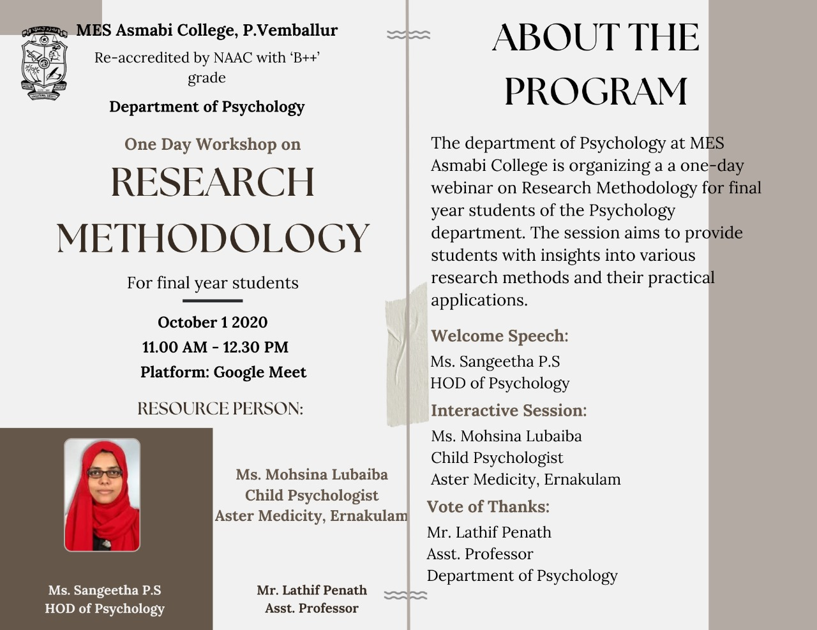
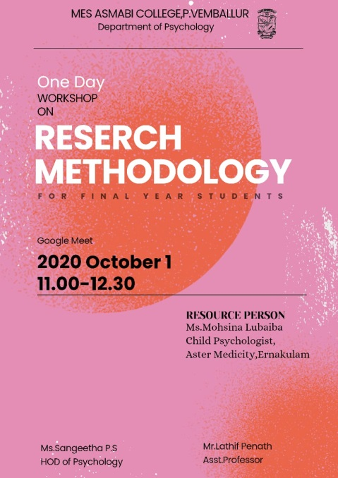

Photograph:

