**Ekabharatha sanklapavvum,vivarthanavum ( Ekabharatha concept and translation)**

In accordance with guidelines of Department of Higher Education ,Government of India ,Department of Hindi MES Asmabi College in association with Bhashasammanwaya vedi (Calicut) an NGO which gives importance to translation and Department of Hindi and P.G Department of Hindi of Sreekrishna College jointly organized a Seminar on the topic. “Ekabharatha sankalpavum,vivarthanavum”. The seminar was held at Seminar hall of Sreekrishna College on 10.01.2024.

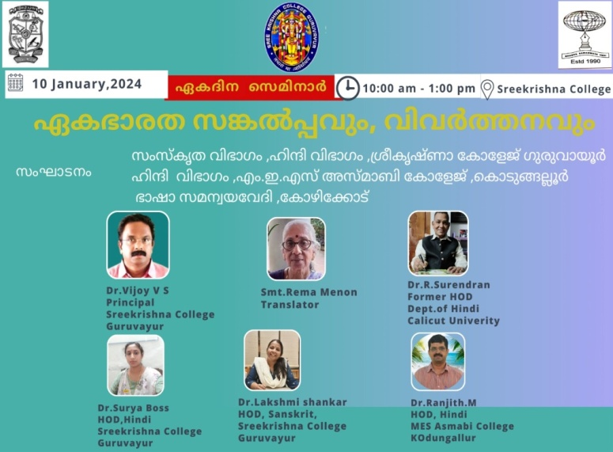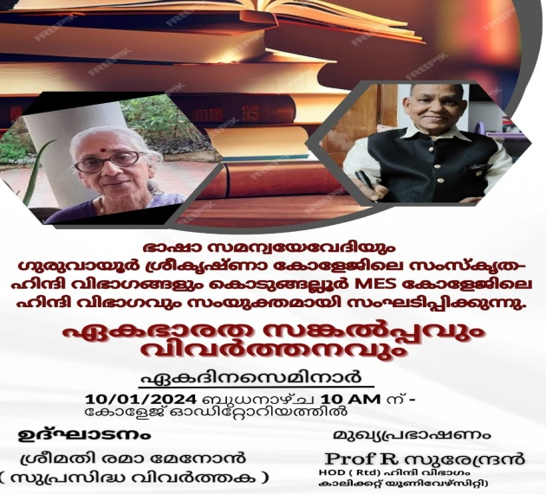

Department of Hindi aims to enhance interaction & promote mutual understanding between people of different states.

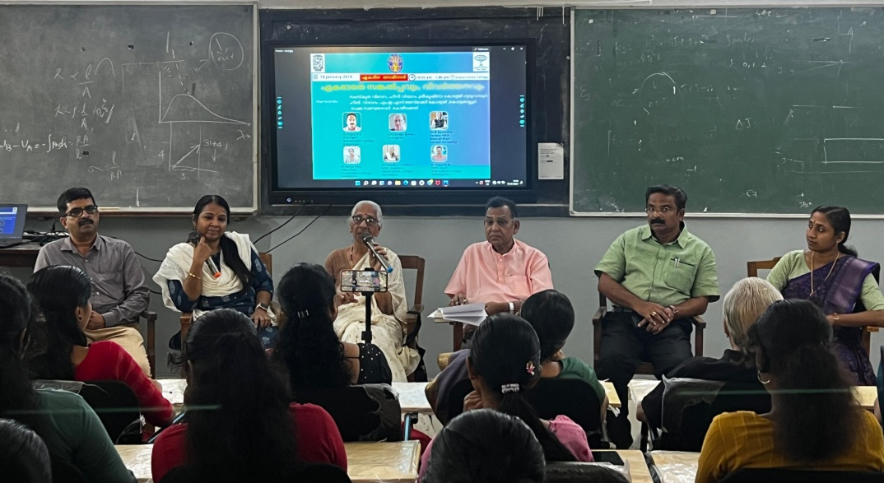

The Seminar was inaugurated by Mrs.Rema Menon, Kendra Sahitya Academy Award Winner who translated works of Paulokoilo and other renowned authors of the world literature to Malyalam. She explained her experiences as a translator.

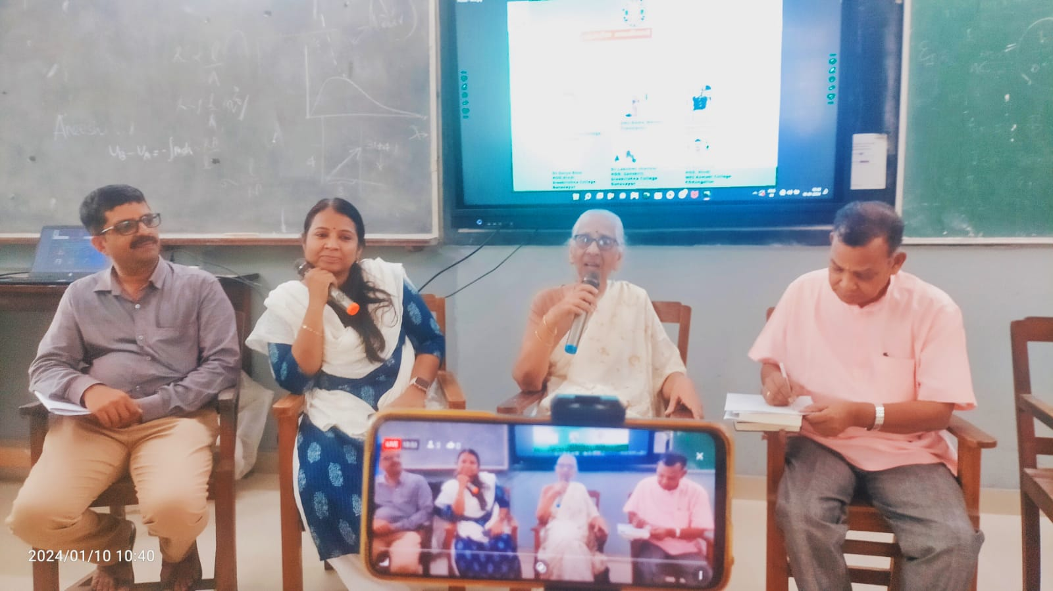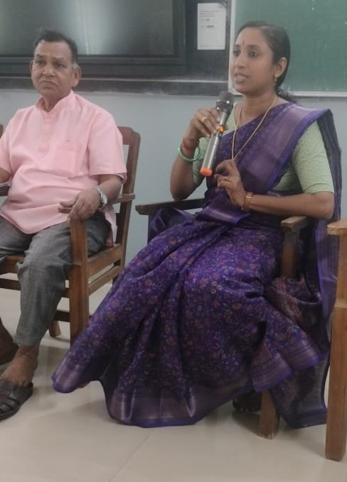

Prof. Dr R Surendran,Former HOD of Department of Hindi,Universtiy of Calicut delivered keynote address Through his speech he delivered the idea of ekbharath sreshtha bharth and how it is described in various literary works of Indian languages.

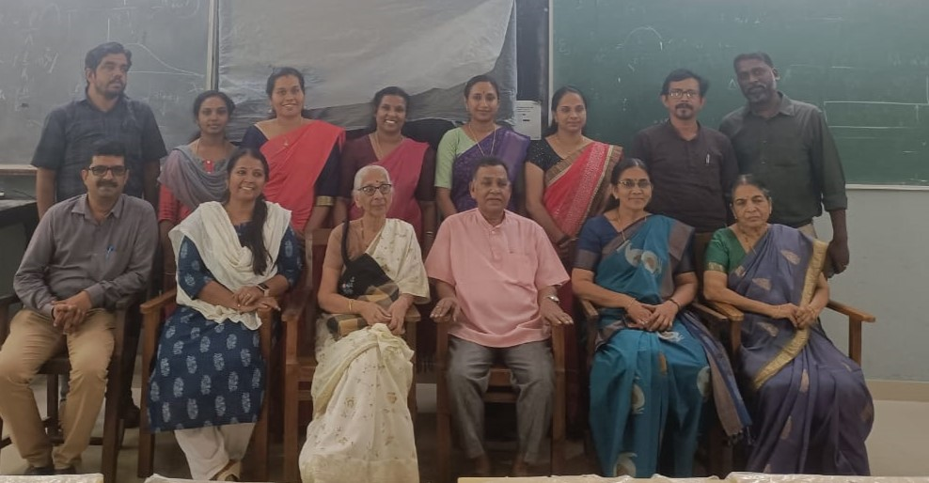

Dr P S Vijoy, Principal Sreekrishna College,Guruvayur presided over the funcation.Dr.Ranjith.M, HOD, Department of Hindi,MES Asmabi College,Dr.Surya Boss HOD of Hindi,Sree Krishna College,Guruvayur,Dr.Lakshmi Shankar,HOD of Sanskirt ,Department of Sanskrit presented papers on various aspects of translation.

Dr.Ranjith .M

HOD

Department of Hindi

MES Asmabi College

P.Vemballur

10.01.2024