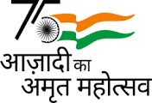

DEPARTMENT OF AQUACULTURE
M E S ASMABI COLLEGE, P. VEMBALLUR

REGIONAL SEMINAR ON
‘CONTRIBUTIONS OF INDIA IN FISHERY POST HARVEST TECHNOLOGY’
(A Programme under the banner of
Azadi Ka Amrut Mahotsav – ‘Celebrating India’s 75th Anniversary of Independence’)

Date and Time: 08/08/2022, 10.00 AM – 1.00PM.
Venue: Seminar Hall.
Context of the talk: ‘Azadi Ka Amrut Mahotsav’ - India celebrates 75th Anniversary of Independence.
Resource Person: Dr. Prajith K K, Sr. Scientist, Fishing Technology Division, CIFT Kochi.
Participants: Students of Final Year B.Sc. Aquaculture and Second Year B. Voc. Fish Processing Technology. FPT Faculties -3, Aquaculture faculties – 3.
Total Male students: 23, Total Female students: 69, Total: 92.

On 08/08/2022. Dr. Prajith K K, Sr. Scientist, Fishing Technology Division, CIFT Kochi spoke on CIFT’s contributions to Fishing Technology and Fishery Post Harvest Technology. The session was held in the college seminar hall from 10 AM to 1 PM. The focus of the talk was on India’s progress in fishery technology post-independence. The programme was held as a part of ‘Azadi Ka Amrut Mahotsav’ celebrations when India celebrates 75th Anniversary of Independence.
In his talk, Dr. Prajith described the importance of fish as a nutritious food item and its significance as a better option for alleviating poverty. The technological achievements of Central Institute of Fisheries Technology (CIFT) in fisheries post harvest technology were highlighted. All types of aquatic resources used as food are highly perishable and so they need to be carefully and hygienically handled post-harvest. The safe and suitable gears for fishing, on-board handling methods, safe transportation to processing areas were elaborated. Landmark achievements of CIFT in fisheries post harvest technology including those in harvesting, handling, processing, quality evaluation, nutrition analysis, value added product preparation, byproduct derivation and packing were detailed. A doubt –clearing session with effective interaction was held after the talk.

Dr. K Kesavan, HoD welcomed the gathering, and Dr. Dhanya P R, Asst. Professor delivered felicitation. Ms. Joyce M Raphael, Student offered vote of thanks. 92 students (final year Aquaculture and second year B. Voc. Fish Processing Technology) 6 faculties (including 3 from B. Voc. FPT) attended the seminar. The programme concluded at 1:00 PM.
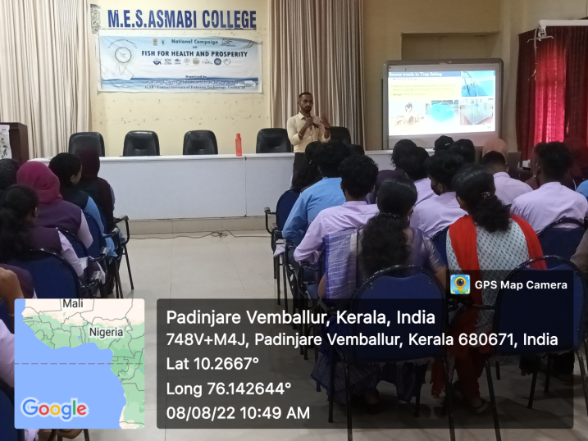
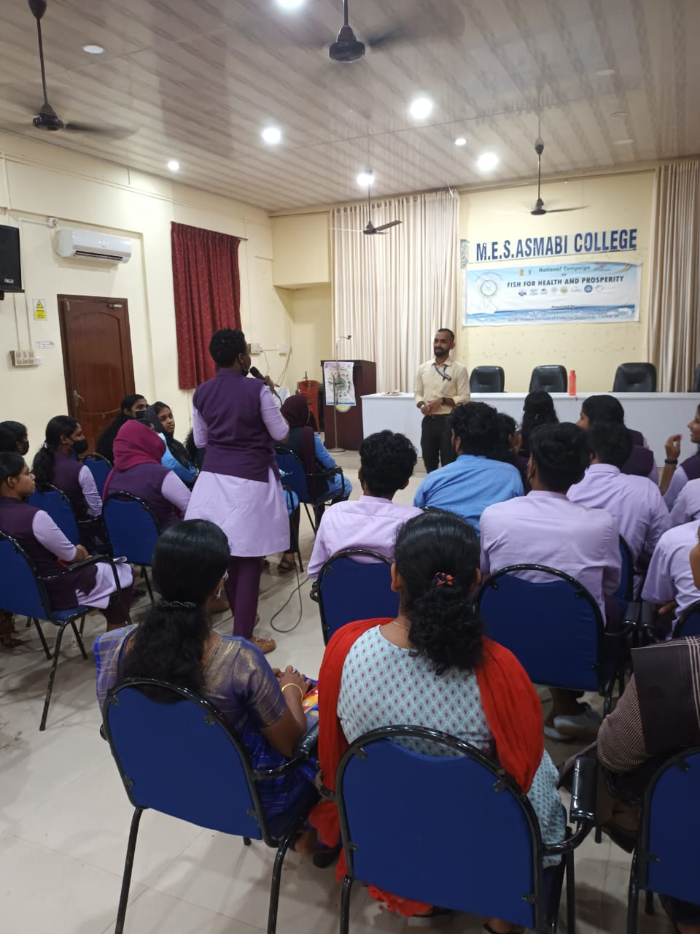
Sd/-
(Dr. Kesavan K, Head of the Department)
-------------------

