DEPARTMENT OF COMPUTER APPLICATION
M E S ASMABI COLLEGE, P. VEMBALLUR -680671

ACADEMIC REPORT OF “EXPERIA-23”
E-Governance Training and Survey
(Best Practice 1 - Experiential Learning through Community Intervention)
Organized in Association with
IIC, MES Asmabi College, P Vemballur

HIGHLIGHTS:
Date: 28th February 2023
Time: 10.30 am to 12.30 PM
Total number of participants: 42 (Students: 5, Faculties:5, Others: 32)

Resource Persons: Aswin M Menon (Final Year BCA)
Aysha Nafrin K A ( ” )
Fathimath Sehala P A ( ” )
Junaid Gafoor (Second Year BCA)
Namsad A N ( ” )
Nabila Nazir (First Year BCA)
Fasin T S ( ” )
Mizna K J ( ” )
Focal areas of the Program:
- How to use online payment systems.
- How to apply for different certificates to LSGD
- How to pay different government taxes.
- How to use bank apps
- How to use net banking system

- The Course of the program:
The programme was organised with the aim to get experiential learning through community intervention to the students of the department by giving training for different online services related to different government sectors and interaction with the community.
The department selected Ward 1 of SN Puram Panchayat as beneficiaries. Though the training program was conducted on 28th February, on 27th February 2023, our students conducted a survey and give awareness about the online services that a normal citizen can be done comfortable from their home using a mobile device. They also welcomed the residents to the training program.
The program started by 10.30 AM at Vekkode Semskarika Nilayam, Kolanippadi. Around 40 participants were present.
Ms Jabin T H (Coordinator and Head of the Department Computer Application) welcomed the gathering. During the welcome speech, she gave a brief about the need of program and introduced the students who will be taking today’s classes.
Principal Dr. A Biju conveyed his best wishes to the program. Dr. K P Sumedhan (Director, Self- financing Courses) delivered felicitations.
The program was inaugurated by Smt. Prakasini Mullasserry (Ward Member). She took a keen interest in conducting the program in her ward and helped us a lot for the success.
Then one of our Final Year BCA student Aswin M Menon lead the training program by demonstrating different payment methods, for applying online certificate to LSGD, payment of building Tax etc.
After a detailed and dynamic presentation, the resource person interacted with the participants for one hour. The interaction session was very effective. Students and faculties from the department helped the participants to try different services through their own mobile devices.
The session for interaction was meaningfully utilised by the faculties and students by clarifying their doubts and getting details of many aspects of the focal themes of the program.

- The Outcome:
The training and the activities followed it have the following outcomes:
- Thorough knowledge about different online payment system.
- The different online services available for the citizens.
- Identifying and applying for different online certificates using mobile/internet technologies
- Knowledge about Internet Banking System and Bank Apps.
- Familiarise different Online Payment Systems, Citizen Online Services, Internet Banking System and Bank Apps.
The session ends up with the awesome feedback session from participant’s side. Ms. Naseema K M (Assistant Professor, Dept. of Computer Application) delivered formal concluding remarks and vote of thanks.
. Addendum:
Programme Brochure and Photos
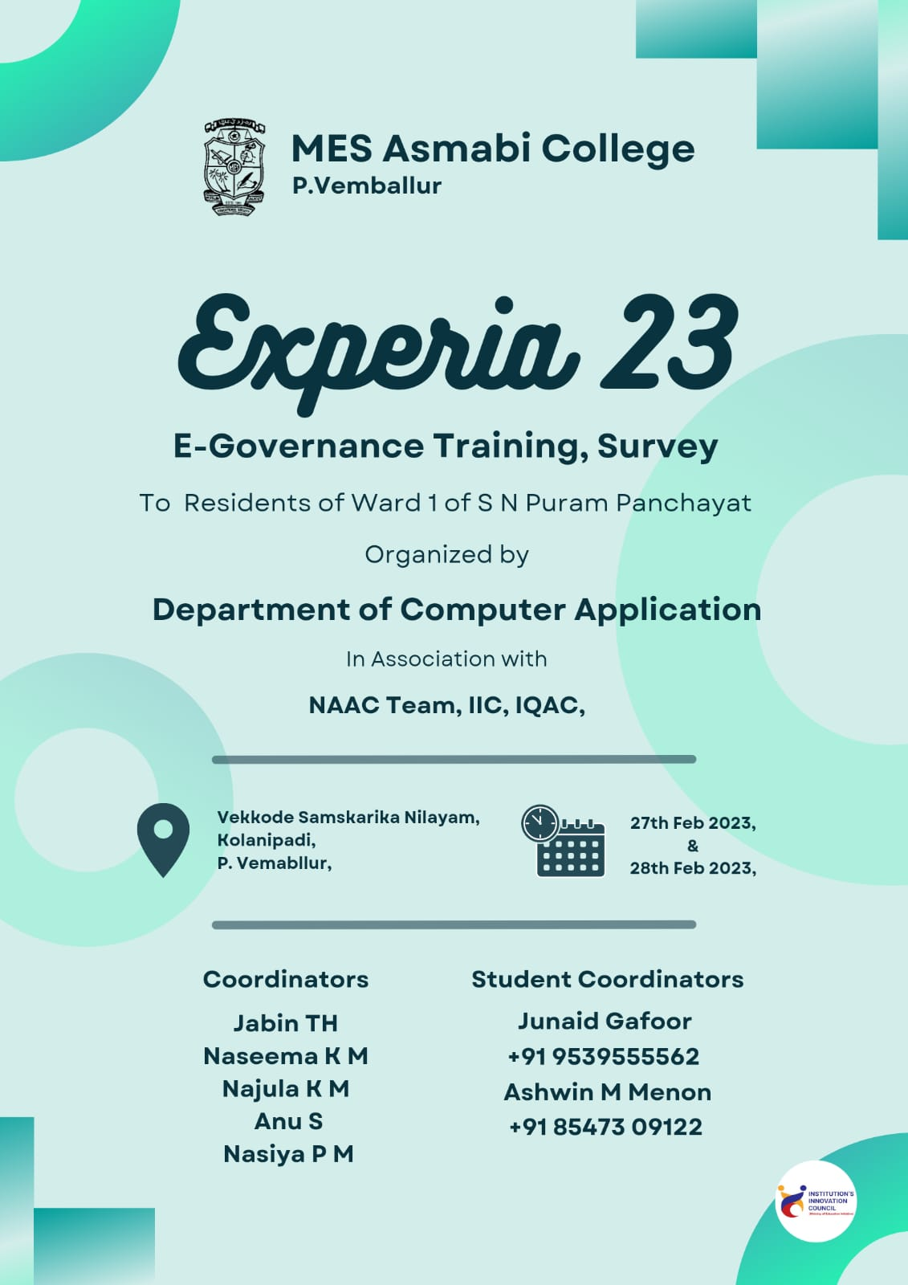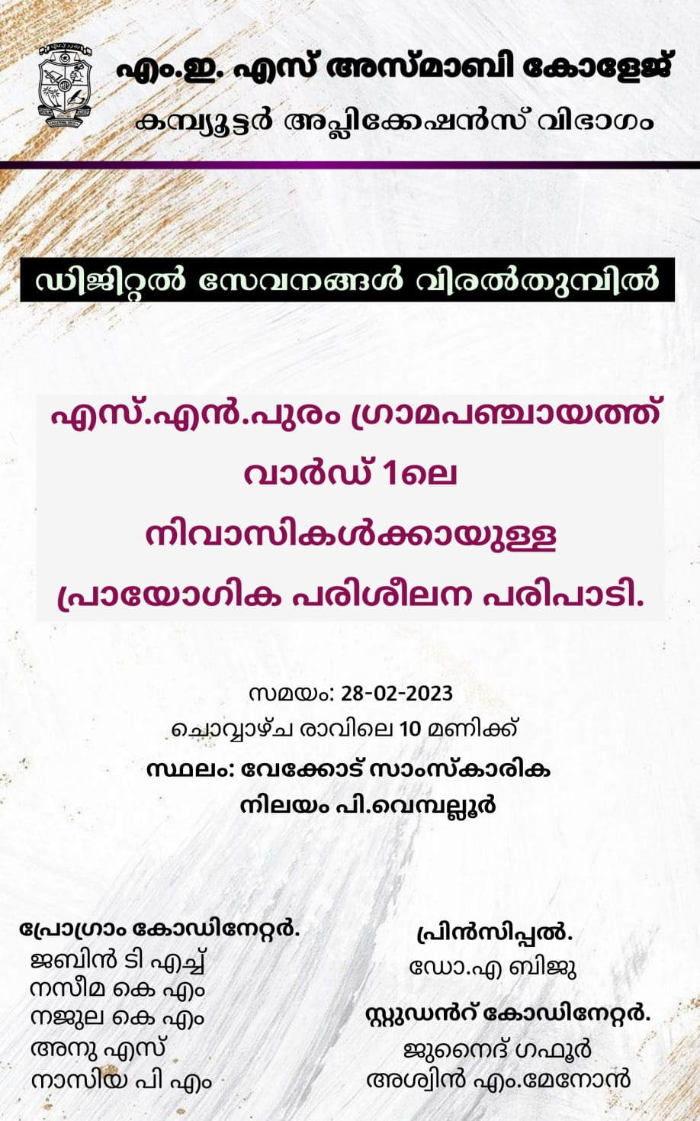

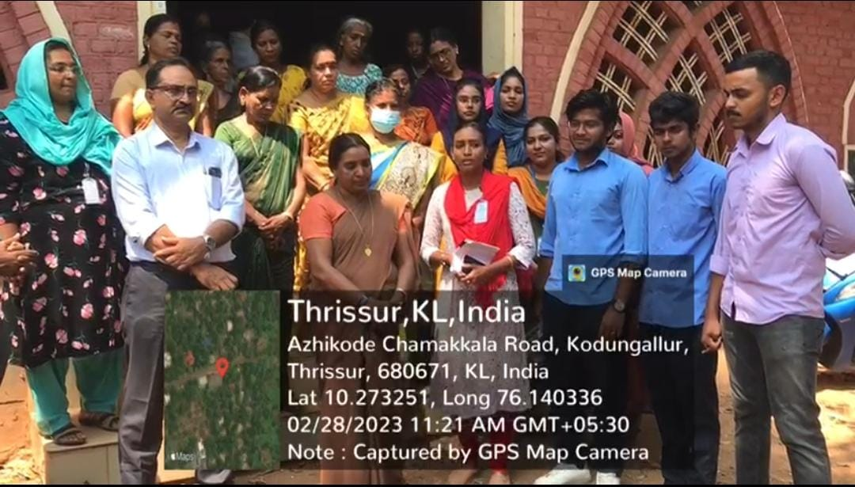
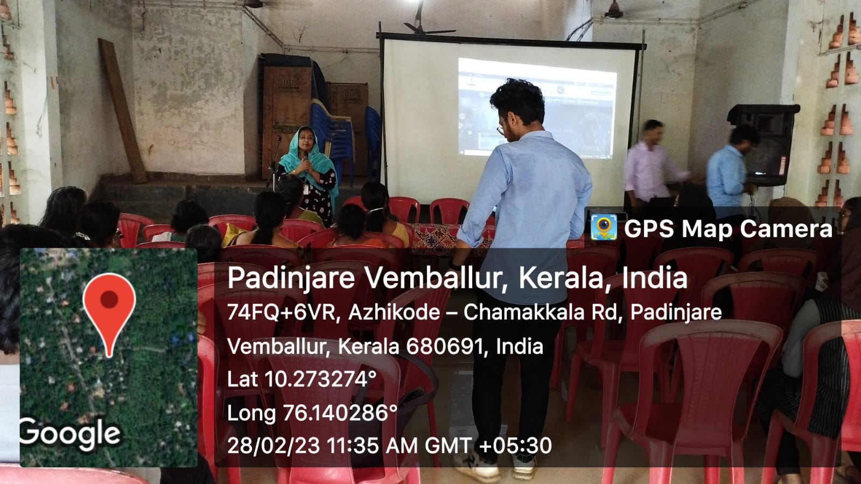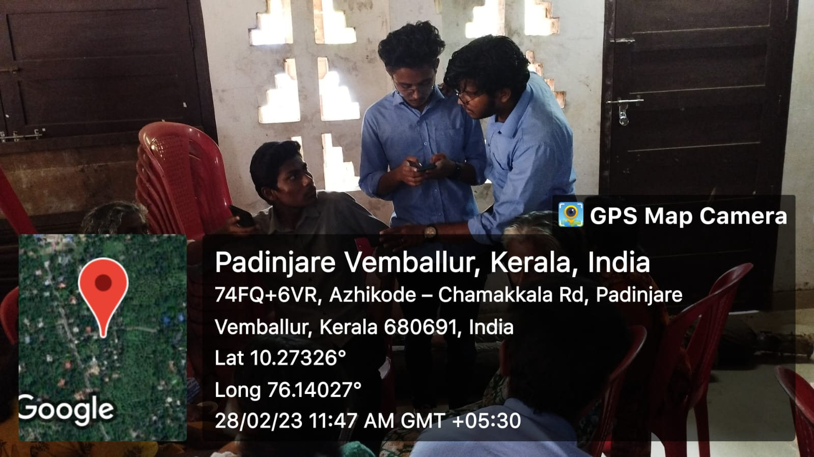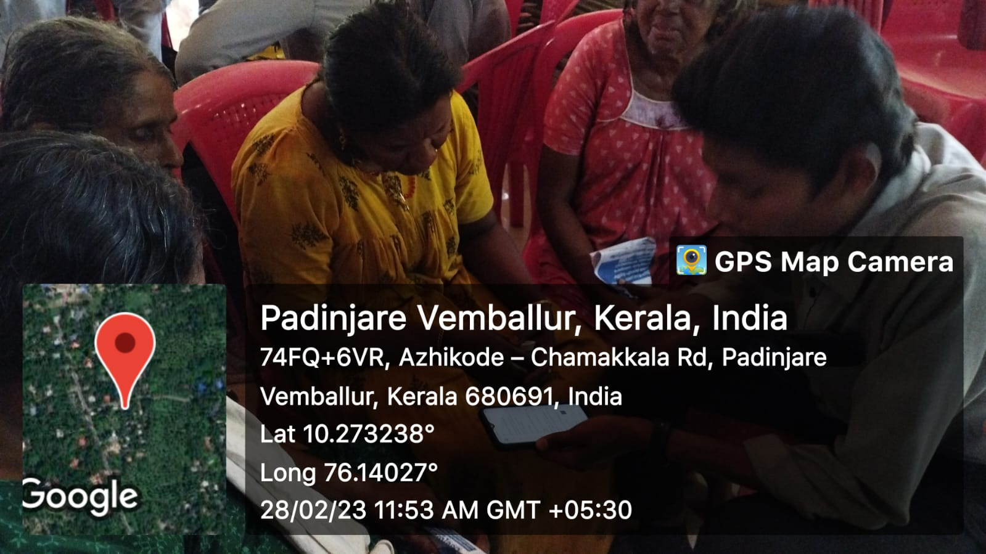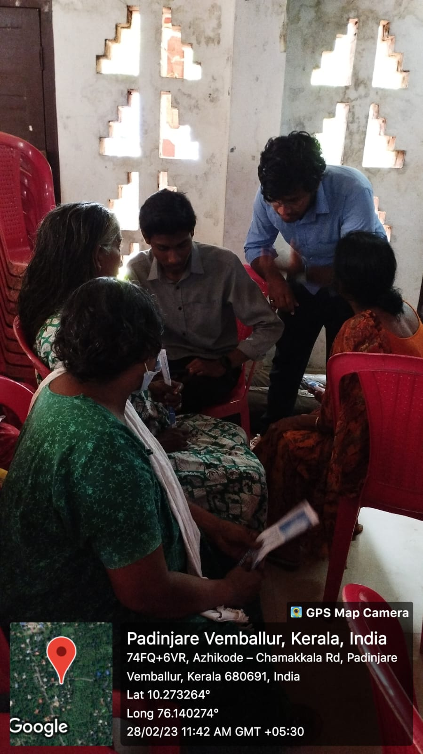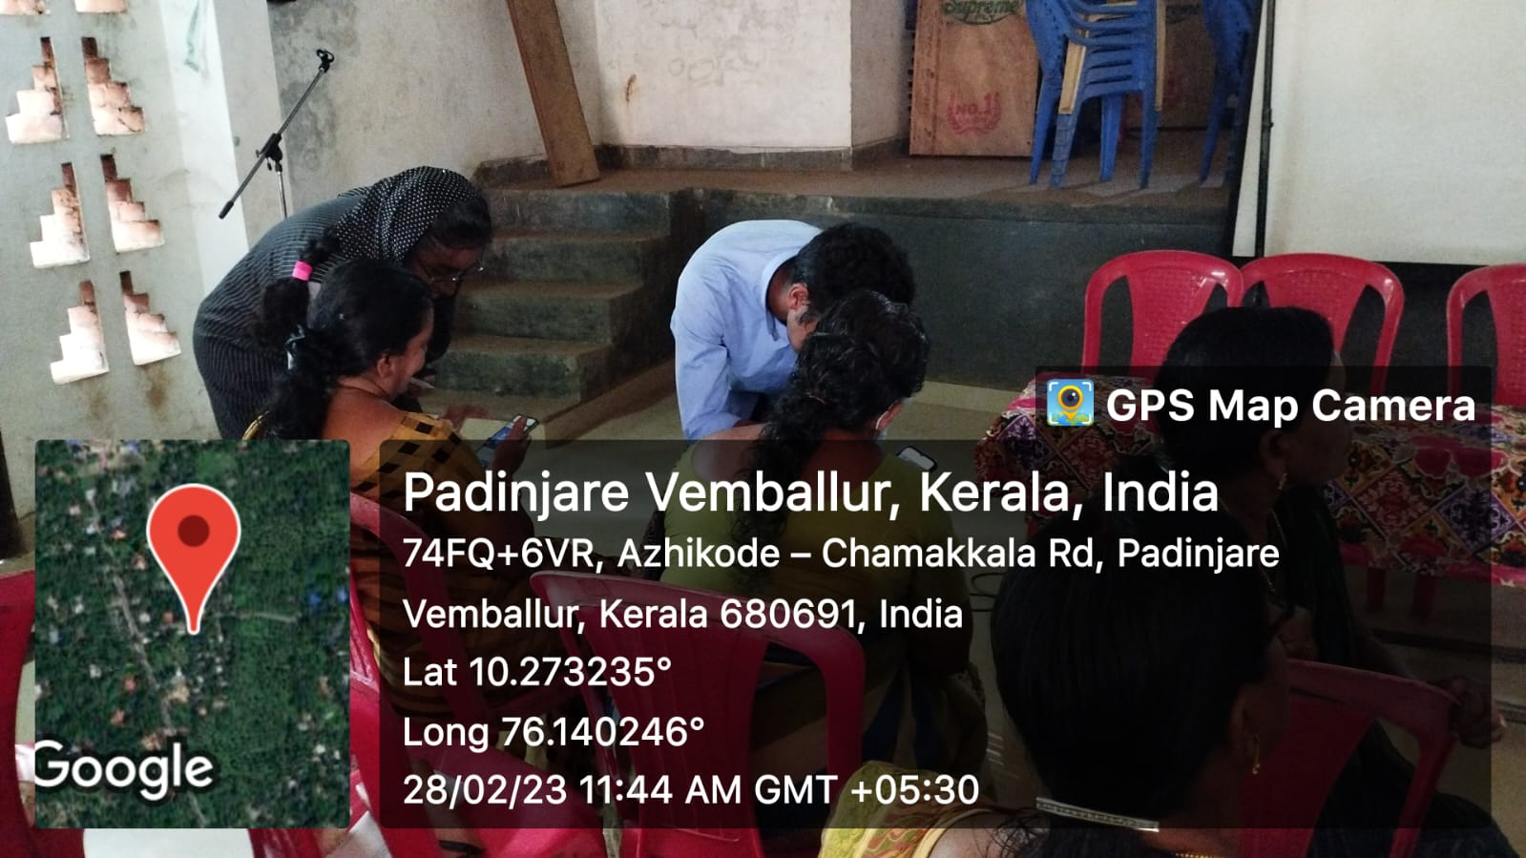

Survey and Awareness about different online services to Community
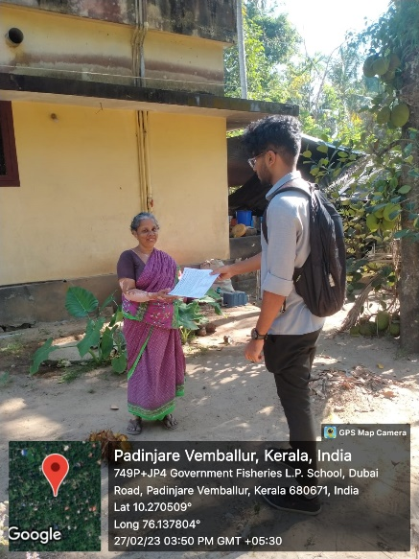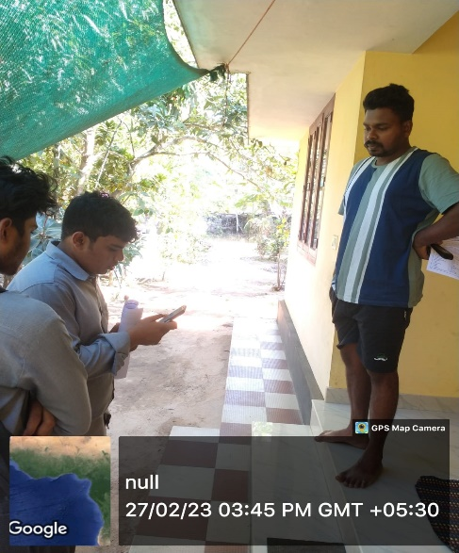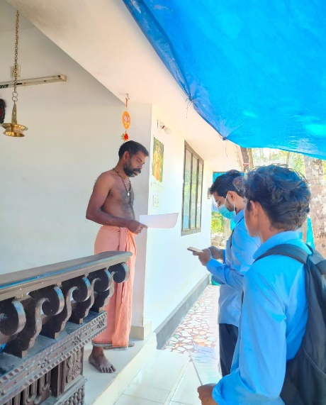
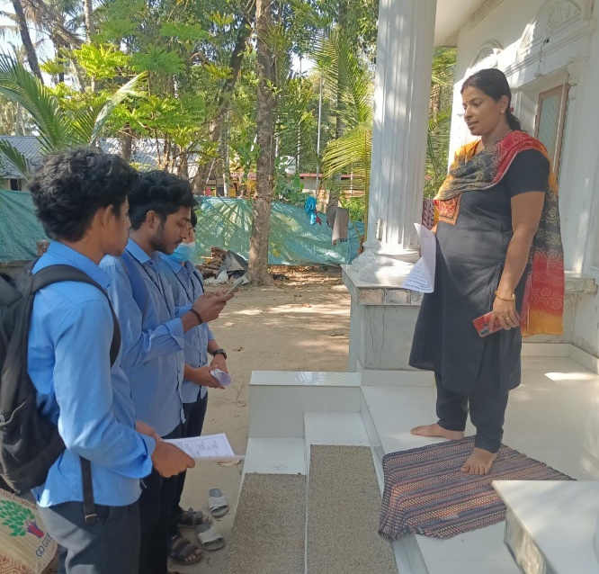
Link for Survey form
https://surveyheart.com/form/63f4c9028f092b076c9f6192

