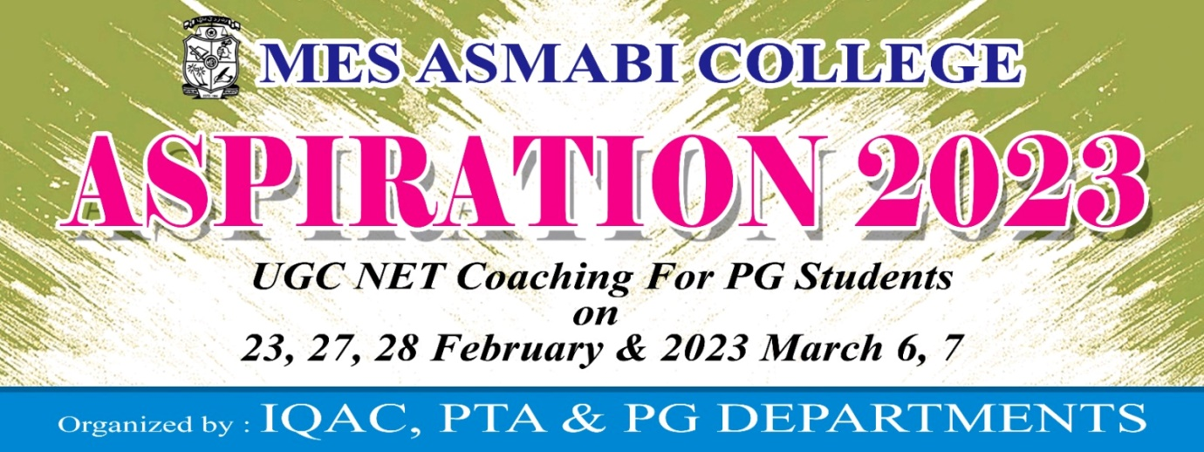

UGC Net Coaching was organized by IQAC, PTA & PG Departments as part of ‘Aspiration 2023’ in MES Asmabi College, P. Vemballur. The program was conducted on 7th March, 2023. The aim of the program was to equip the PG students to face UGC NET examination. Ms Shabnam Sakiya, Junior Research Fellow, Research Department of English took the session. 46 students from the Research Department of English participated in the program.
