**MES ASMABI COLLEGE, P.VEMBALLUR**

**DEPARTMENT OF MASS COMMUNICATION & JOURNALISM**

GREEN INITIATIVE ACTIVITIES

MES Asmabi College aims at grooming socially responsive young students equipped with necessary skill sets to meet the different challenges they may meet in life. Based on the realization that climate change and environmental sustainability is a global challenge, grooming environmentally conscious, responsive and responsible youth who value the nature and strive to preserve them is a major action plan of the college. To achieve this goal, college promotes varied green initiative activities.

In connection with college green initiative activities, the department has selected 12 students for coordinating departmental green activities. The department faculty coordinator is Ruksana PA.

**The names of the student coordinators are as follows**

1. 1st Year
2. Fatima Khadija Nazar
3. Sreeraj PR
4. Krishna A.B
5. Sreevishnu KS
6. 2nd Year
7. Shabeena PU
8. Sreekutty KS
9. Afsal CA
10. Gangalakshmi PR
11. 3rd Year
12. Ashna Sageer
13. Safvana PS
14. Aneina Manoj
15. Shifana VR

**Mass Green Initiative Activities**

**Activity 1: Green Screen Series**

There are plenty of movies and short films that educate students about environmental issues and promote the need for protecting the nature. The department organized the movie screening activity in connection with college green initiatives on 2nd March 2023. Two short films, ‘Voice of Trees’ & ‘And I Call Him My Father’ were screened. Both the films show how a common man started planting trees in a piece of barren land and turned it into a forest.

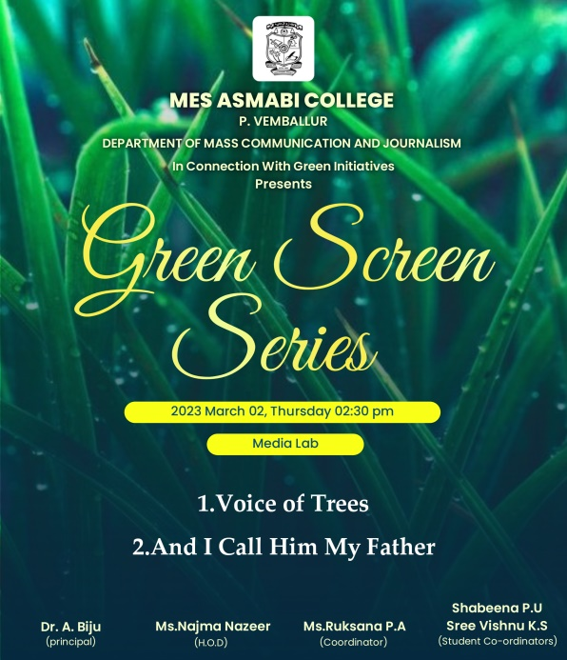 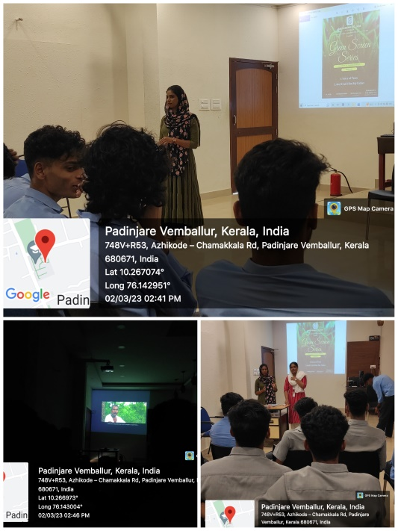

**Activity 2: Off Campus Workshop on Nature Photography**

In connection with college green initiative activities, the department organized a one day workshop on Nature Photography on 9th March 2023. It was an off campus workshop conducted at Shangukulangara Sacred Grove. It helped the students know more about sacred groves and need to protect it.

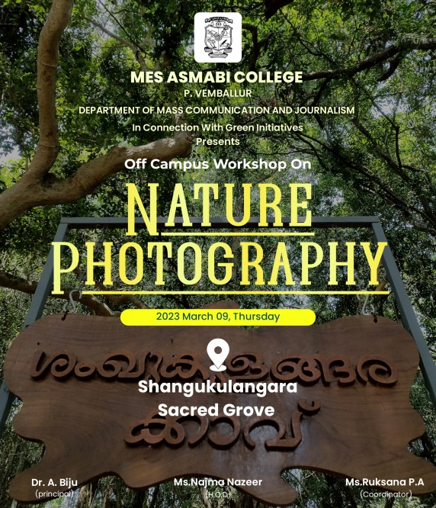 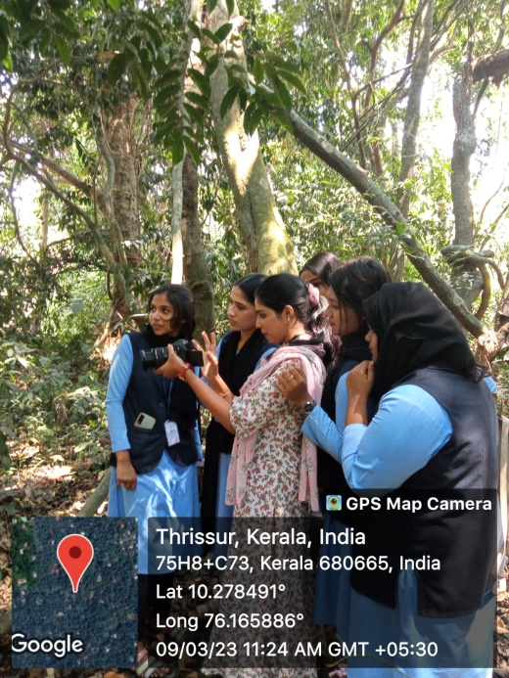

**As an educator, there are so many things we can do to make our classroom and college greener. Teaching students about green practices now creates a lifelong interest in saving the planet. So we teachers and students are very much happy to be a part of these green initiative activities.**

Name of the Coordinator Name of the HOD

Ruksana PA Najma Nazeer