REPORT ON LECTURE POLITICS IN CINEMA

**Place : Media Lab**

**Date: 27/10/2022 2:00 PM – 3:00 PM**

# Lecture on “ Politics In Cinema” organised by B.Voc Digital Film Production

*Participant’s Profile: Students from first and third semester B.voc digital film production*

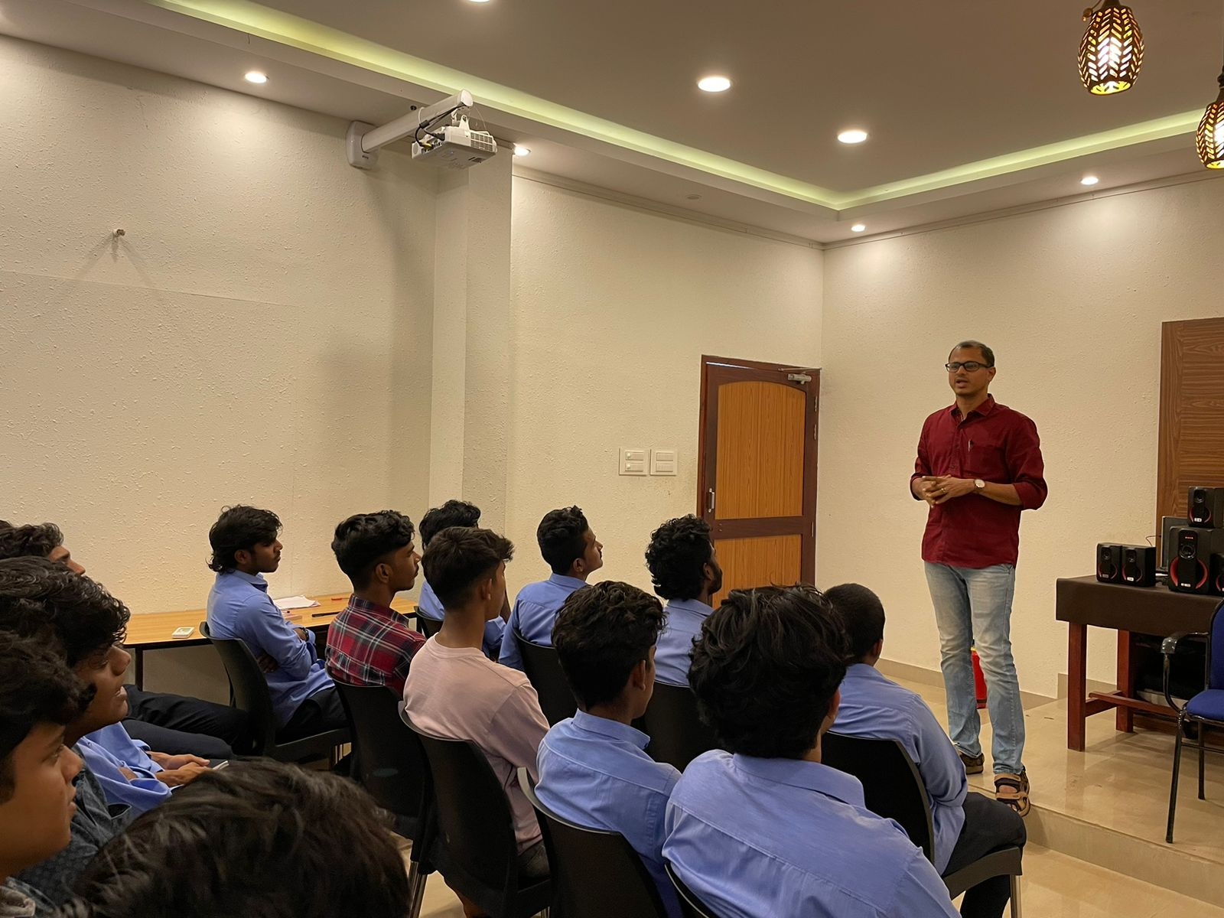

The lecture on topic “Politics in cinema” organised by department of B.voc digital film production. The lecture presented by Resource person **Dr. Sanand Sadanandan**, Department of political science on 27/10/2022 at 2 pm in Media lab. Mr. Mynag Suresh, HOD of B.voc digital film production invited an all of us in to this lecture. After welcome speech Sanand sir started his class. He discussed politics in world and Indian films. He is also discussed the similarities in Korean films and Indian films.

In Indian film industry, especially Tamil , Kannada and Telugu industries are highly related to politics. M.G.R , Jayalalitha and Ramoji Rao are the major examples. In Malayalam film industry , the focusing areas of the films are slavery, gender equality and urbanization etc. He is also explained the film Palunku, Kaazhcha etc.

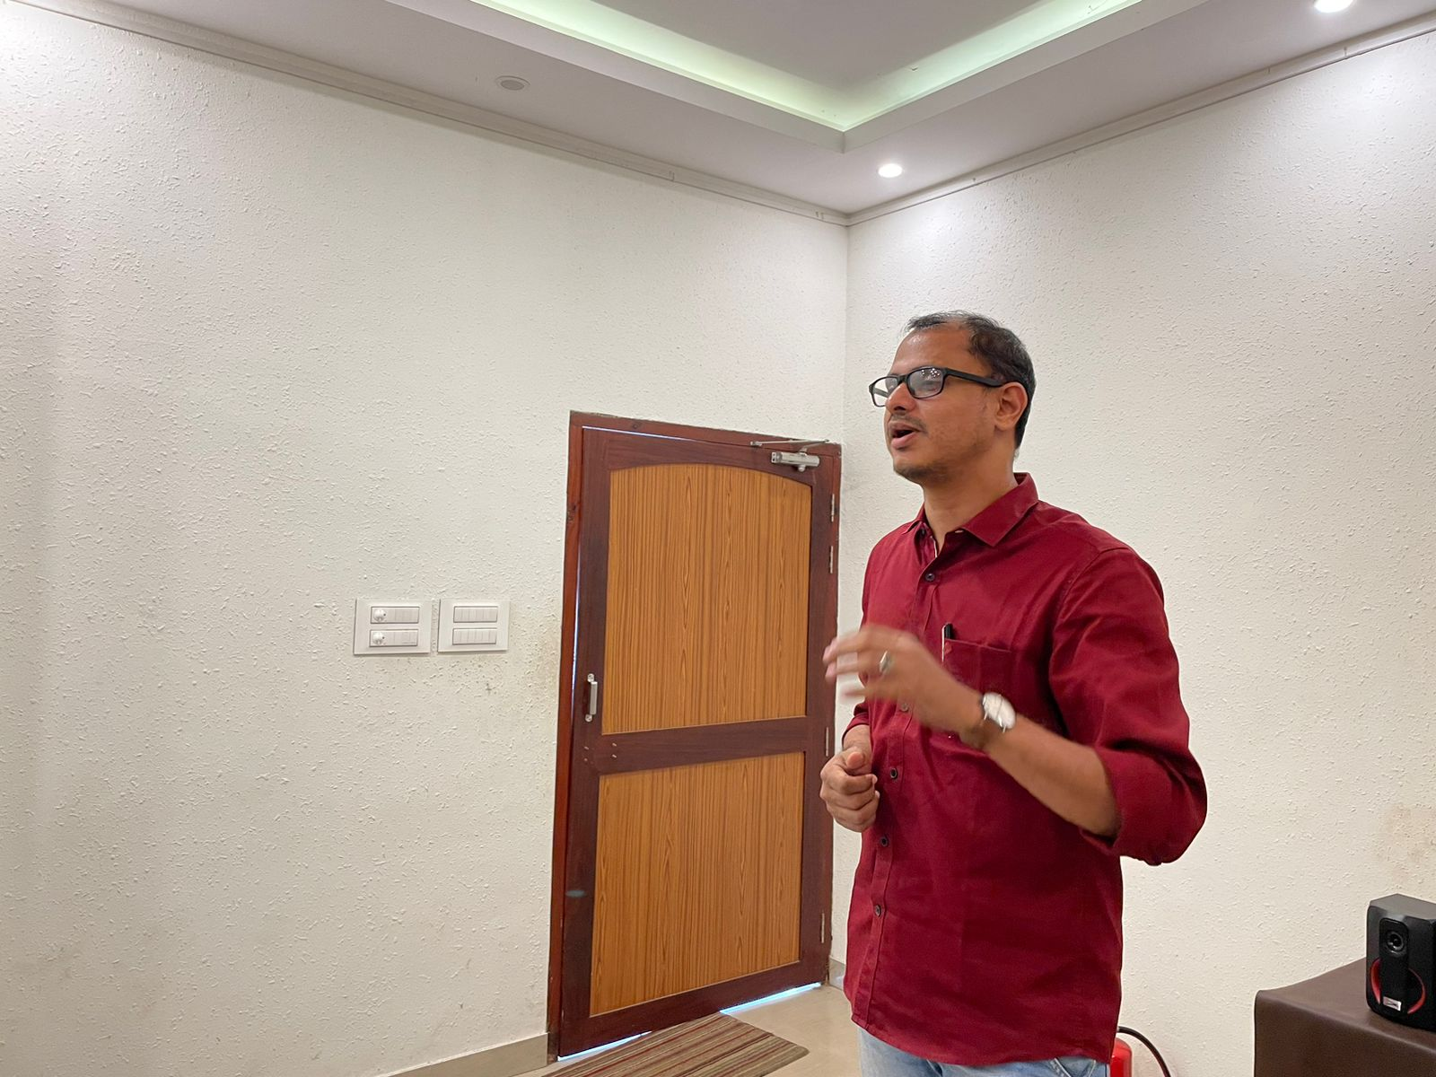

There was a doubt clearance session after the class. After this session, Mr. Mynag Suresh, HOD of B.voc digital film production, delivered vote of thanks. The session is ended at 3pm.

COORDINATOR

Mynag Suresh HOD, B.VOC DFP