**MES Asmabi College, P.Vemballur**

**Report of Meet the Author**

**21/06/2021**

PG & Research Department of English organized Reading Day Celebrations in the College. *Meet the Author* programme was one of the best events in the two-days reading day celebrations. Malayalam writer, Ms Shumaiza was the chief guest of the event .The session was conducted online. Principal Dr. A. Biju presided over the event. Writer as well as former student of our department, Ms. Shumaiza addressed the gathering. She motivated our students about how she managed to write and publish her debut novel *Ammutty*. It was indeed an inspiring session for the participants. The session came to an end with vote of thanks by Assistant Professor of English, Smt. Sabitha M.M.

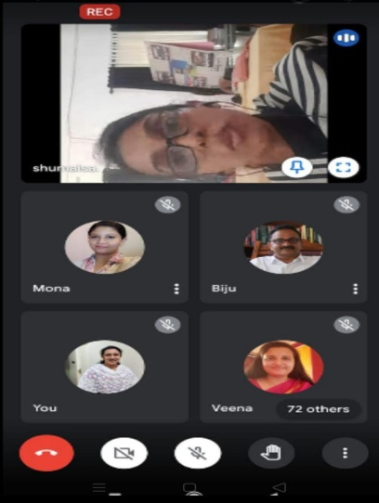

HOD Coordinator

Dr. Muralikrishnan T.R. Ms. Mona VM